# INTRODUCTION

## INTRODUCTION

Diagnosing chronic diseases, such as diabetes, cardiovascular issues, and respiratory disorders, presents a considerable challenge due to the intricate nature of symptoms and disease progression. Traditional diagnostic approaches, though effective, often involve labor-intensive manual analysis and interpretation, which can be susceptible to errors and inefficiencies. With the increasing incidence of chronic conditions worldwide, there is an urgent need for innovative methods to enhance the accuracy and efficiency of diagnostics.

Additionally, the sheer volume of patient data—ranging from electronic health records (EHRs), laboratory test results, medical imaging, to clinical notes—can be overwhelming for manual processing. The need for systems that can handle multi-modal data and extract meaningful clinical insights in a timely and accurate manner is critical. Chronic disease diagnosis not only demands high precision but also the ability to monitor disease progression and suggest treatment pathways tailored to individual patients.

Traditional diagnostic approaches, while clinically valuable, typically rely on **manual interpretation** of diverse medical inputs including physical exams, imaging results, laboratory reports, and patient histories. These methods are **time-consuming, labor-intensive**, and can vary in accuracy due to **human subjectivity**, fatigue, or inconsistencies in expertise across practitioners. In large healthcare settings or regions with limited resources, these factors can lead to **delayed diagnoses**, **misdiagnoses**, or **missed opportunities for early intervention**, negatively impacting patient outcomes.

Adding to this challenge is the **rapid increase in chronic disease prevalence worldwide**, driven by aging populations, sedentary lifestyles, and environmental factors. Healthcare systems are now burdened with **massive volumes of patient data**, including Electronic Health Records (EHRs), diagnostic test results, wearable sensor data, and unstructured clinical notes. Manually extracting meaningful patterns from such **multi-modal and high-dimensional data** is not only inefficient but often infeasible within the required clinical timeframes.

This growing data complexity calls for **advanced, intelligent systems** capable of handling, analyzing, and interpreting medical data in real time. Chronic disease diagnosis demands **high precision**, **early signal detection**, and the ability to **predict disease trajectories** and recommend personalized care strategies. These needs have spurred the integration of **Artificial Intelligence (AI)** into diagnostic support systems.

#### INTRODUCTION

Artificial intelligence (AI) has emerged as a pivotal technology in healthcare, offering advanced solutions to support and improve diagnostic processes. AI-driven diagnostic support systems employ sophisticated Machine Learning (ML) and Deep Learning (DL) techniques to analyze large volumes of medical data with greater precision. These systems are capable of automating the evaluation of medical images, detecting intricate patterns, and generating predictions, which helps reduce the burden on healthcare professionals and enhances diagnostic performance.

AI models trained on large datasets are capable of generalizing from historical cases, thereby allowing them to detect anomalies, spot trends, and forecast outcomes. These models can serve as decision-support tools, helping physicians make faster and more evidence-based decisions. For instance, AI systems can flag early signs of diabetic retinopathy in eye scans or detect plaque formations in cardiovascular scans that might otherwise be missed during manual review.

Machine Learning encompasses a variety of techniques, including neural networks and fuzzy logic, which contribute to automating and optimizing diagnostic workflows. These methods enable AI systems to learn from data and continually improve their predictive accuracy. Deep Learning, a specialized area within ML, utilizes Convolutional Neural Networks (CNNs) to conduct advanced image analysis without the need for manual feature extraction, leading to more accurate detection and classification of disease-related features in medical images.

The application of AI in chronic disease detection has the potential to significantly transform healthcare by providing more accurate and timely diagnosis, facilitating early intervention, and improving overall patient care. However, challenges remain, such as issues with data quality, algorithm transparency, and integration into existing healthcare practices. Addressing these challenges is crucial for maximizing the benefits of AI-driven diagnostic systems. A detailed review of AI-driven diagnostic support systems for chronic disease detection, highlighting recent technological advancements, evaluating their effectiveness, and exploring current limitations.

#### MOTIVATION

**Improved Patient Outcomes**: Leveraging AI in diagnostics aims to enhance patient care by enabling early detection of chronic illnesses, improving prognosis through timely intervention.

This includes reducing hospital readmissions, avoiding complications through proactive monitoring, and improving the quality of life for patients with long-term conditions.

**Enhanced Diagnostic Accuracy**: Advanced machine learning algorithms analyze complex data, reducing the likelihood of human error and increasing diagnostic precision.

The system can reduce inter-observer variability, where different doctors interpret the same data differently. Standardized outputs from AI improve consistency across institutions and locations.

**Early Detection of Chronic Diseases**: The system focuses on identifying diseases such as cancer, heart disease, and diabetes in their early stages, when treatment is most effective.

**Comprehensive Data Analysis**: By integrating patient medical history, test results, and imaging data, the system provides a holistic view for better diagnosis.

This also enables longitudinal tracking of a patient's health, where trends over time (e.g., steadily rising blood sugar or narrowing arteries) can be used to predict future risks and adjust treatment.

**Actionable Insights for Decision-Making**: The tool offers predictive analytics and risk assessments, enabling healthcare providers to make informed decisions swiftly.

**Integration with EHR Systems**: Seamless compatibility with electronic health record systems ensures widespread adoption and streamlined workflows in healthcare facilities.

**Workload Reduction for Medical Professionals**: Automating data analysis and diagnostics allows practitioners to focus on patient care, reducing their workload and preventing burnout.

It is especially useful in under-resourced settings where specialist access is limited. By handling routine screenings, AI allows doctors to prioritize critical cases.

**Accessibility and Scalability**: The system is designed to be accessible across various healthcare setups, ensuring its impact is broad and scalable.

**Research-Driven Development**: The project emphasizes training the model on diverse datasets to achieve high accuracy and generalizability, addressing biases and ensuring reliability.

**Focus on Real-Time Processing**: Incorporating real-time data processing ensures the system delivers timely insights critical for immediate clinical decisions.

**User-Centric Design**: The system aims to present its findings in an intuitive and user-friendly interface, with visualizations, alerts, and confidence scores that make it easier for healthcare professionals to act on AI recommendations.

#### PROBLEM DEFINITION

Chronic diseases such as cancer, heart disease, and diabetes are leading causes of death and disability globally, placing immense pressure on healthcare systems and economies. Early detection of these conditions is critical for successful treatment and improved patient outcomes. However, traditional diagnostic methods often fall short due to their reliance on manual processes that are time-consuming, error-prone, and limited in their ability to analyze complex and voluminous healthcare data. As a result, many chronic conditions are diagnosed at advanced stages, when treatment options are less effective, leading to higher mortality rates and increased healthcare costs. These challenges are compounded by the rising demand on healthcare professionals, who are often overwhelmed with large workloads, further increasing the likelihood of diagnostic delays and errors.

The limitations of traditional diagnostics are not just technical but operational—patients often undergo fragmented care across multiple specialists, leading to redundant tests and miscommunication. AI systems can help centralize patient records and provide a unified view of a patient’s health journey.To address these pressing challenges, there is a need for an innovative diagnostic support system powered by artificial intelligence (AI). Such a system can leverage advanced machine learning algorithms to analyze diverse datasets, including medical histories, imaging studies, and laboratory results, with speed and accuracy far beyond human capabilities. The use of predictive analytics and real-time data processing will enable the system to detect early signs of chronic illnesses, providing actionable insights and risk assessments for medical practitioners. This capability not only enhances diagnostic accuracy but also facilitates timely interventions, significantly improving patient outcomes. Moreover, by automating the analysis of complex medical data, the system can alleviate the workload of healthcare professionals, allowing them to focus on patient care and decision-making.

A critical aspect of the proposed system is its seamless integration with existing electronic health record (EHR) systems. This compatibility ensures that the solution is accessible and scalable across diverse healthcare settings, enabling widespread adoption and impact. By streamlining workflows and providing reliable diagnostic support, the system can transform chronic disease management, making it more efficient and effective. Ultimately, this AI-driven solution has the potential to revolutionize healthcare by improving diagnostic precision, reducing the burden on healthcare practitioners, and delivering better outcomes for patients worldwide.

#### OBJECTIVE OF THE PROJECT

**Problem statement**

Chronic diseases such as cancer, heart disease, and diabetes are significant global health challenges due to their high prevalence, severe outcomes, and associated costs. Early detection is critical for improving patient outcomes, yet traditional diagnostic methods, reliant on manual analysis of complex patient data, are often time-consuming, error-prone, and inadequate for handling the growing volume of healthcare information. These limitations lead to delayed diagnoses, reduced treatment efficacy, and increased strain on healthcare systems. An AI-driven diagnostic support system is essential to address these issues by leveraging machine learning algorithms to analyze diverse datasets, identify early disease indicators, and provide actionable insights for timely interventions. By integrating seamlessly with existing electronic health record (EHR) systems, such a solution can enhance diagnostic accuracy, reduce medical practitioners’ workloads, and transform chronic disease management for better patient care and outcomes.

The objective also includes improving healthcare accessibility in remote and underserved regions by deploying AI tools that require minimal infrastructure. AI can help democratize healthcare by ensuring that even primary health centers can access high-quality diagnostic support without waiting for specialist opinions.

## Proposed System

The proposed system can be classified into mainly two steps after acquiring the input data from the user who are using our application and the other one is getting the result by processing the input data. These steps are: Extraction Method and Features estimation and Extraction.

These two main stages—**data acquisition** and **feature extraction**—are supported by a backend AI engine trained on labeled datasets. Once the features are extracted, the system uses classification algorithms (e.g., Random Forests, CNNs, or LSTM networks depending on data type) to predict disease presence or progression. The result is presented as a report that includes a probability score, suggested diagnosis, and recommendations for further testing or treatment.

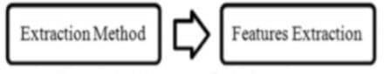

**Fig 1.4.1 Steps of Extraction**

#### ORGANIZATION OF THE REPORT

The report gives the reader a summary of the project and details the methodical execution of the developed working application. It also provides an overview of the project's potential for implementation.

Chapter 1: Introduction is about the AI DRIVEN DIAGNOSTIC CENTER SUPPORT FOR DETECTION OF CHRONIC DISEASES motivation, definition and objective of the project.

Chapter 2: System requirement specifies all the requirements that are needed for developing the application, which includes hardware and software requirements.

Chapter 3: Literature survey details about Chronic diseases detection using Advanced techniques and covers the reason behind developing the project.

Chapter 4: System Design and UML diagrams are shown.

Chapter 5: Entire source code and results of the Implementation are shown.

Chapter 6: All the testing strategies that are involved to test the model, has been described in this section.

Chapter 7: Future enhancement section provides the details about the extension of the project that are to be implemented in the future and what can be added in future.

Chapter 8: References

# SYSTEM

# SPECIFICATIONS

## 2.SYSTEM SPECIFICATIONS

#### 2.1 SOFTWARE SPECIFICATIONS

Software requirements define the essential tools, platforms, libraries, and frameworks needed to design, develop, deploy, and maintain an application. These requirements ensure that the system performs efficiently, aligns with organizational infrastructure, and meets the desired objectives. Unlike features built into the software itself, these requirements often necessitate separate installation, configuration, and regular updates. Meeting these prerequisites ensures smooth operation, scalability, and compatibility across various environments.

In the context of an **AI-driven diagnostic support system**, the software requirements are integral for handling complex processes, including data ingestion, cleaning, feature extraction, machine learning model training, real-time predictions, and front-end user interaction. These tools and frameworks collectively empower the system to process extensive datasets, provide diagnostic insights, and deliver results through an intuitive interface.

**Key Components of the Software Framework**

1. **Data Processing Tools** These tools are essential for ingesting, cleaning, and pre-processing raw healthcare data. They prepare the input for subsequent stages of machine learning. Examples include:
   * **ETL (Extract, Transform, Load) Tools**: Tools like Apache NiFi and Talend streamline data ingestion and transformation.
   * **Data Cleaning Libraries**: Python libraries such as Pandas and NumPy are used to handle inconsistencies, remove noise, and standardize datasets.
2. **Machine Learning Frameworks** AI models rely on robust machine learning frameworks to facilitate training and inference:
   * **TensorFlow or PyTorch**: These frameworks enable the creation and training of neural networks for predictive modeling.
   * **Scikit-learn**: Provides algorithms for classification, regression, and clustering tasks during data analysis.
   * **Keras**: A user-friendly API for building deep learning models, integrated with TensorFlow.
3. **Visualization Tools** Presenting diagnostic insights in an understandable format is crucial for healthcare professionals:
   * **Matplotlib and Seaborn**: Python libraries for generating graphs and plots that visualize data trends and insights.
   * **Dash or Tableau**: Platforms for creating interactive dashboards that provide a holistic view of diagnostic outcomes.
4. **Front-End Development** The user interface must offer an intuitive and efficient experience:
   * **React, Angular, or Vue.js**: Popular JavaScript frameworks for building responsive and user-friendly web interfaces.
   * **Bootstrap**: A CSS framework that ensures the interface is visually appealing and easy to navigate.
5. **Back-End and Integration Frameworks** The back-end processes must ensure seamless integration with existing healthcare systems:
   * **Flask or Django**: Python frameworks for developing robust back-end services.
   * **FastAPI**: Lightweight and optimized for high-speed REST API development.
   * **Integration APIs**: Middleware tools such as HL7 FHIR for connecting the diagnostic system with Electronic Health Records (EHRs).

**Functional and Performance Objectives**

The software system must address the following objectives to meet healthcare industry standards:

1. **Seamless Integration**
   * The system must integrate smoothly with existing EHR systems and healthcare databases.
   * It should maintain compatibility with various data formats to ensure interoperability without disrupting existing workflows.
2. **High Accuracy**
   * The AI models should deliver consistent and reliable predictions. High diagnostic precision is crucial to building trust among healthcare professionals and reducing false-positive or false-negative results.
3. **Superior Performance**
   * The system must outperform traditional diagnostic methods in terms of speed, accuracy, and scalability.
   * Real-time data processing capabilities should allow for instant predictions and actionable insights during clinical decision-making.
4. **Scalability and Adaptability**
   * The platform should be scalable to accommodate increasing patient data and evolving healthcare demands.
   * It should be adaptable for deployment in diverse settings, from large hospital networks to rural clinics.
5. **User Experience and Accessibility**
   * A well-designed user interface ensures an intuitive experience for healthcare providers.
   * Accessibility features, such as multi-language support or offline functionality, enhance usability in various environments.

By fulfilling these software requirements and objectives, the proposed system will empower healthcare professionals with a reliable, efficient, and effective diagnostic tool, capable of transforming chronic disease management and improving patient outcomes.

**Software Requirements**

| **Component** | **Description** |
| --- | --- |
| **Operating System** | Windows OS – chosen for its compatibility with development tools and ease of deployment. |
| **Programming Language** | Python – selected for its simplicity and rich ecosystem in data science and machine learning. |
| **Libraries Used** | - **NumPy**: Efficient numerical computation  - **Pandas**: Structured data manipulation  - **Matplotlib & Seaborn**: Data visualization  - **Scikit-learn**: Classical machine learning models  - **Keras**: Deep learning model development using neural networks |
| **Framework** | Flask – A lightweight web application framework used to serve the AI model and handle user interaction. |

**Table 2.1:** Requirement of Software required for the Project Development

#### 2.2 HARDWARE SPECIFICATIONS

Hardware requirements refer to the physical system specifications that must be met to ensure the reliable and efficient operation of the software. These requirements are critical for the performance of computationally intensive tasks such as **data preprocessing, model training, inference, and real-time predictions**, which form the backbone of an AI-driven diagnostic support system.

In the context of applications leveraging **deep learning** and handling large medical datasets or high-resolution images, robust computational power becomes paramount. These systems must process extensive data volumes, train complex machine learning models, and deliver rapid insights—all without bottlenecking or crashing under high workloads. Failure to meet these hardware specifications can lead to:

* **Performance Degradation**: Slow processing speeds during critical operations like training or inference.
* **Memory Overloads**: Insufficient memory allocation can result in crashes, interrupting workflows and reducing efficiency.
* **Unstable Execution**: Hardware that is not optimized for deep learning computations may fail to execute tasks consistently, hampering reliability.

**Key Components for Hardware Specifications**

1. **Processor (CPU)**:
   * **Minimum Requirement**: Multi-core processors with a high clock speed (e.g., Intel i5 or AMD Ryzen series).
   * **Recommended Requirement**: Advanced processors such as Intel i7/i9, AMD Ryzen 7/9, or equivalent. For deep learning, higher clock speeds and increased thread counts significantly improve performance.
   * A powerful CPU is essential for initial preprocessing tasks, user interface responsiveness, and managing communication between system components.
2. **Graphics Processing Unit (GPU)**:
   * **Minimum Requirement**: Dedicated GPU (e.g., NVIDIA GTX series or AMD Radeon series).
   * **Recommended Requirement**: High-performance GPUs such as NVIDIA RTX 30xx series or NVIDIA A100 designed for machine learning and deep learning workloads.
   * GPUs accelerate **matrix computations** and neural network training by parallelizing operations. They are critical for processing large datasets, particularly when working with high-resolution medical images.
3. **Memory (RAM)**:
   * **Minimum Requirement**: At least 8 GB of RAM for basic tasks.
   * **Recommended Requirement**: 16–32 GB RAM or higher, depending on the system’s data processing and training requirements.
   * Adequate RAM ensures smooth operation during multitasking and prevents memory bottlenecks when handling large datasets.
4. **Storage**:
   * **Minimum Requirement**: SSD storage with a capacity of 256 GB or more for faster data access and software execution.
   * **Recommended Requirement**: SSDs of 512 GB or 1 TB to accommodate large datasets, trained models, and diagnostic outputs. For enterprise-level systems, **NVMe SSDs** are preferred for their enhanced speed.
   * Storage must be optimized for quick read/write operations to manage real-time data flows.
5. **Network Connectivity**:
   * **Minimum Requirement**: Stable internet connection for cloud-based deployments.
   * **Recommended Requirement**: High-speed network interfaces (e.g., gigabit Ethernet or Wi-Fi 6) for seamless integration with remote servers and Electronic Health Record (EHR) systems.
   * Network capability ensures uninterrupted access to cloud resources, data synchronization, and real-time updates.
6. **Operating System**:
   * Compatibility with major operating systems such as Windows 10/11, Linux distributions (Ubuntu, CentOS), or macOS.
   * Enterprise environments might rely on server-grade OSs like Windows Server or Red Hat Enterprise Linux for scalability and security.
7. **Cooling Systems**:
   * Deep learning workloads and high GPU utilization can generate significant heat. Proper cooling solutions, including liquid cooling or high-performance fans, are recommended to maintain system stability and prevent thermal throttling.
8. **Power Supply Unit (PSU)**:
   * Adequate PSU wattage is necessary to support GPUs and other hardware components without power fluctuations.

**Enterprise-Grade Hardware for Scalability**

For large healthcare facilities or research institutions, the following additional components may be required:

* **High-Performance Computing (HPC) Clusters**: Clusters of GPUs and CPUs working in parallel to manage large-scale model training.
* **Cloud Integration**: Access to cloud services like AWS, Microsoft Azure, or Google Cloud for distributed computing and scalable storage solutions.
* **Hardware Compatibility Lists (HCLs)**: Verification tools to ensure hardware is certified for selected software platforms and operating systems.

**Ensuring Compatibility**

The hardware configuration must be fully compatible with the selected software tools, platforms, and frameworks (e.g., TensorFlow, PyTorch). **Hardware compatibility lists (HCLs)** can be consulted to verify that components such as GPUs, motherboards, and storage devices meet the specific requirements of the software environment. Ensuring compatibility minimizes integration risks and enhances system reliability.

By meeting these hardware requirements, the system can effectively process medical data, train deep learning models, and deliver actionable insights to healthcare professionals, ensuring smooth and efficient operation.

**Hardware Requirements**

| **Component** | **Specification** |
| --- | --- |
| **RAM** | 8 GB – Sufficient for handling moderate data volumes and ML workflows. |
| **Processor** | Intel iCore (i5 or higher recommended) – Provides multi-threading support for faster processing of AI algorithms. |
| **Hard Disk** | 2 TB – Ample storage capacity for datasets, models, logs, and backups. |

**Table 2.2:**  Requirement of Hardware Required for Project Development

# LITERATURE

# SURVEY

## 3.LITERATURE SURVEY

#### EXISTING SYSTEM

* + 1. **Evaluation of artifcial intelligence techniques in disease diagnosis and prediction Authors:** Nafseh Ghafar Nia1, Erkan Kaplanoglu1, Ahad Nasab1

##### Published Year: 2023

The research paper titled "Evaluation of Artificial Intelligence Techniques in Disease Diagnosis and Prediction," authored by Nafseh Ghafar Nia, Erkan Kaplanoglu, and Ahad Nasab in 2023, presents a detailed exploration of the transformative impact of artificial intelligence (AI) on medical diagnostics and disease prediction. The authors provide an extensive review of AI methodologies, particularly machine learning (ML) and deep learning (DL), which have introduced innovative approaches to automating disease detection and significantly enhancing diagnostic precision. AI-based models such as Convolutional Neural Networks (CNNs) and Support Vector Machines (SVMs) are highlighted for their ability to process complex medical datasets, including CT scans, X-rays, and MRIs, with remarkable efficiency. By identifying intricate patterns and abnormalities within these datasets, these technologies facilitate early detection of diseases such as cancers, cardiovascular conditions, and neurological disorders—areas where timely intervention often leads to better prognoses and improved patient outcomes. Furthermore, the paper underscores the ability of AI frameworks to reduce the workload for healthcare professionals, enabling them to focus on patient-centered care while minimizing errors associated with manual diagnostic processes.

The authors emphasize how DL models excel at handling large volumes of medical data, automatically extracting relevant features, and enhancing diagnostic workflows. Specific applications of AI discussed in the paper include tasks such as segmentation (isolating critical areas of medical images, like tumors or lesions), classification (categorizing disease markers or abnormalities), and fusion (integrating data from multiple sources to achieve higher diagnostic accuracy). Predictive modeling is particularly spotlighted as a valuable tool for forecasting disease progression, assessing risk levels, and identifying high-risk individuals based on both historical and real-time data. The study showcases successful implementations of AI in diagnosing conditions such as Alzheimer’s disease, Parkinson’s disease, and breast cancer, achieving diagnostic precision that often surpasses human expertise. For example, AI algorithms can detect subtle signs of breast cancer in mammograms with greater accuracy and consistency than human radiologists, reducing the rate of missed diagnoses.

Beyond diagnostics, the paper explores the use of AI in real-time patient monitoring, where wearable devices and IoT-enabled systems collect health data continuously. These AI-powered tools process patient-specific data to provide personalized insights, enabling dynamic disease management and empowering individuals to make informed decisions about their health. The combination of predictive analytics and real-time monitoring positions AI as an essential component of modern healthcare, contributing to early interventions and improved quality of life for patients with chronic or progressive diseases.

While the benefits of AI in medical diagnostics are evident, the authors also address critical challenges that impede its widespread implementation. One significant obstacle is the reliance on large, annotated datasets for training AI models. Curating such datasets requires substantial resources and domain expertise, which may not be readily available in resource-limited settings. Additionally, the computational complexity of DL architectures often necessitates high-performance hardware such as GPUs, which can be prohibitively expensive for smaller healthcare facilities. Ethical considerations further complicate the adoption of AI in healthcare, including concerns about data privacy, algorithm bias, and the potential misuse of AI-generated insights. Ensuring transparency and trust in AI systems is essential for gaining widespread acceptance among healthcare professionals and patients alike.

Looking ahead, the authors envision a future where AI becomes deeply integrated into healthcare systems, revolutionizing diagnostic practices, clinical workflows, and patient care. By delivering highly accurate diagnostics and personalized treatment plans, AI has the potential to transform healthcare into a more efficient, reliable, and accessible system. The paper emphasizes that achieving this vision requires collaboration across disciplines—AI researchers, medical professionals, policymakers, and ethicists must work together to address the existing limitations and establish ethical frameworks that prioritize patient rights and data security. Furthermore, innovations in AI technology, such as the development of explainable AI (XAI) and the democratization of computational resources, are essential for ensuring equitable access to AI-driven solutions globally.

Ultimately, the study concludes with optimism, asserting that continuous advancements in AI hold the promise of a brighter future for global healthcare. From improving early detection rates to enabling personalized care, AI is poised to make diagnostics more efficient and accurate, paving the way for a healthcare system that is better equipped to meet the growing challenges of disease diagnosis and management.

**3.1.2 Artificial intelligence in disease diagnostics: A critical review and classification on the current state of research guiding future direction**

**Authors**: Milad Mirbabaie , Stefan Stieglitz ,Nicholas R. J. Frick

##### Published Year: 2021

The research paper titled "Artificial Intelligence in Disease Diagnostics: A Critical Review and Classification on the Current State of Research Guiding Future Direction," authored by Milad Mirbabaie, Stefan Stieglitz, and Nicholas R. J. Frick in 2021, presents an insightful and in-depth analysis of how artificial intelligence (AI) is reshaping disease diagnosis and medical practice. The paper evaluates the current applications of AI, classifying the different techniques utilized across healthcare domains while examining the challenges and opportunities they present. AI systems, including neural networks, decision trees, and support vector machines (SVMs), are recognized for their ability to revolutionize diagnostic accuracy, efficiency, and consistency. By integrating data from multiple sources, processing vast and complex datasets, and applying advanced algorithms, these tools help reduce diagnostic errors, alleviate cognitive strain on healthcare professionals, and address time constraints often associated with traditional medical practices. The study highlights that AI has the potential to significantly improve healthcare outcomes by enabling clinicians to focus on more personalized and patient-centered care.

The paper systematically categorizes AI methods, including supervised learning, unsupervised learning, and deep learning (DL), while explaining their specific applications in disease diagnosis. Supervised learning techniques, such as SVMs and neural networks, excel in tasks like disease classification and prediction by relying on labeled datasets to identify disease-specific patterns. Unsupervised learning approaches, on the other hand, analyze unlabeled data to uncover hidden structures, groupings, or trends, making them suitable for exploratory diagnostics. DL models, including Convolutional Neural Networks (CNNs) and Recurrent Neural Networks (RNNs), are noted as particularly impactful in processing multidimensional data, such as high-resolution medical images or time-series data from heart rate monitors. These models have demonstrated exceptional performance in specialties like dermatology (analyzing skin conditions), cardiology (detecting heart abnormalities), and oncology (identifying cancerous tissues). By automating tasks like segmentation (dividing medical images into regions of interest), classification (differentiating between normal and abnormal findings), and fusion (combining multimodal data sources), DL techniques greatly enhance the diagnostic process. However, a significant limitation discussed is the "black box" nature of many AI models, where their inner workings and decision-making processes remain opaque, potentially limiting trust and acceptance in clinical settings.

The authors emphasize the need to overcome various obstacles to fully realize the potential of AI in healthcare. One critical challenge is the scarcity of large, diverse, and high-quality datasets required to train AI models effectively. Many existing datasets lack standardization or fail to represent diverse populations, which can introduce bias and reduce the reliability of diagnostic predictions across different demographic groups. The computational intensity of training DL models presents another barrier, as many healthcare institutions, especially those in resource-limited settings, may lack access to the necessary hardware, such as high-performance GPUs or advanced cloud infrastructure. Ethical considerations also play a pivotal role, with concerns surrounding data privacy, algorithmic bias, and the lack of transparency in AI decision-making processes. The paper argues that addressing these ethical challenges is essential for building trust among healthcare providers and patients, as well as ensuring equitable AI adoption in both high-resource and underserved environments.

To pave the way for the successful integration of AI into healthcare systems, the study outlines several forward-looking recommendations. The development of explainable AI (XAI) models is highlighted as a priority, as these models provide insights into how predictions are made, enabling clinicians to better understand and trust AI-generated diagnostics. Building larger, more diverse datasets is equally critical to improving AI model robustness and reducing biases. Moreover, the authors stress the importance of collaborative efforts among AI developers, healthcare practitioners, and policymakers. Such partnerships are necessary for creating systems that are not only technically sound but also aligned with ethical standards, regulatory requirements, and the practical needs of clinical environments. Another recommendation involves integrating AI tools seamlessly into existing healthcare workflows to complement, rather than replace, the expertise of medical professionals.

In conclusion, the paper positions AI as a transformative force with the potential to revolutionize disease diagnosis and improve healthcare outcomes globally. Through enhanced diagnostic accuracy, faster decision-making, and the ability to process complex data, AI has the capability to address many of the challenges faced by modern healthcare systems. However, realizing this potential will require addressing current limitations, fostering interdisciplinary collaboration, and prioritizing ethical considerations. With continuous advancements in technology, the authors remain optimistic that AI-driven diagnostic systems will evolve into indispensable tools for clinicians, paving the way for more efficient, reliable, and patient-centric healthcare practices.

**3.1.3 Applications of Machine Learning Predictive Models in the Chronic Disease Diagnosis**

**Sequences Authors:** Gopi Battineni, Getu Gamo Sagaro, Nalini Chinatalapudi, Francesco Amenta

##### Published Year: 2020

The research paper titled "Applications of Machine Learning Predictive Models in the Chronic Disease Diagnosis Sequences," authored by Gopi Battineni, Getu Gamo Sagaro, Nalini Chinatalapudi, and Francesco Amenta in 2020, extensively explores the transformative role of machine learning (ML) in diagnosing and managing chronic diseases (CDs). Chronic diseases, including diabetes, cardiovascular diseases, chronic obstructive pulmonary disease (COPD), and liver conditions, contribute significantly to global morbidity and healthcare costs due to their complex, lifelong management requirements. The study underscores how ML predictive models can revolutionize healthcare by enabling early detection, accurate diagnosis, and forecasting disease progression. These capabilities not only improve patient outcomes but also support healthcare systems in resource optimization and strategic planning.

The paper systematically reviews 453 articles from leading medical and scientific databases, narrowing down its analysis to 22 studies that best illustrate the strengths and limitations of ML approaches in chronic disease diagnostics. Prominent ML algorithms, such as Support Vector Machines (SVM), Logistic Regression (LR), clustering methods, and Artificial Neural Networks (ANNs), are highlighted as effective tools for disease classification and prediction. These algorithms demonstrate high accuracy in identifying early disease markers, stratifying at-risk populations, and supporting data-driven decision-making. For example, SVM and LR have shown reliability in modeling relationships between disease predictors and outcomes, such as predicting cardiovascular risk based on patient vitals and demographics. Meanwhile, ANNs are particularly powerful in uncovering complex, non-linear patterns in multidimensional data, making them suitable for tasks like forecasting COPD exacerbations and classifying different stages of diabetes. By integrating diverse data types, including clinical records, medical imaging, and real-time sensor data, these models provide a comprehensive picture of a patient's health status.

The paper emphasizes the variability in the performance of ML models due to the diversity of datasets, algorithms, and clinical use cases. No single model is universally optimal for diagnosing all chronic diseases; instead, the success of an algorithm largely depends on its alignment with the specific characteristics of the disease, the quality of the dataset, and the objective of the analysis. This context-specific applicability highlights the need for tailored model selection and evaluation when integrating ML into clinical workflows.

Despite the promise of ML in chronic disease diagnosis, the study addresses several challenges that must be overcome for its widespread adoption. One major obstacle is the dependency on high-quality, diverse, and annotated datasets for model training and validation. Many datasets lack standardization, are fragmented, or do not adequately represent diverse populations, which can lead to biased predictions and reduced generalizability. Ethical concerns, particularly regarding patient data privacy and security, further complicate data collection and sharing processes, limiting the availability of rich, unified datasets. Moreover, integrating predictive models into healthcare workflows often involves logistical challenges, such as upgrading hospital infrastructure, training personnel, and ensuring seamless interoperability with existing Electronic Health Records (EHR) systems. The study also critiques the current over-reliance on supervised learning models and suggests that exploring unsupervised learning and deep learning methods may reveal new insights and improve diagnostic accuracy. Deep learning algorithms, in particular, have the potential to address some of the complexities in medical imaging and genomic data, enabling more precise and dynamic diagnostics.

The authors advocate for the establishment of standardized protocols to improve the scalability, reliability, and ethical deployment of ML tools in medicine. Standardized methodologies for data collection, model validation, and performance assessment are vital for ensuring consistency and interoperability across healthcare systems. Additionally, the paper highlights the importance of fostering interdisciplinary collaboration among AI researchers, medical practitioners, and policymakers. Such collaboration is essential to bridge the gap between theoretical advancements and practical implementations, ensuring that ML models meet the real-world needs of healthcare environments.

The study concludes by reinforcing the transformative potential of ML predictive models in chronic disease management. With continuous advancements in algorithm development, computational power, and data integration, these tools could significantly mitigate the global burden of chronic diseases. They enable proactive healthcare approaches, where diseases are detected and managed before severe complications arise, ultimately reducing costs and improving patient quality of life. The authors propose future research directions, including refining algorithms to handle complex medical imaging and multi-omics data, developing equitable AI frameworks to prevent bias, and designing robust implementation strategies for diverse healthcare settings. By addressing these areas, ML predictive models can unlock unprecedented opportunities in personalized medicine and reshape global healthcare practices for a more efficient, accessible, and patient-centered future.

#### DISADVANTAGES OF EXISTING SYSTEMS

Although ML models show promise in terms of efficiency and accuracy in the diagnosis of chronic illnesses, a number of drawbacks were observed:

**1. Data Dependency**

Machine learning models require large, diverse, and high-quality datasets for effective training, which presents significant challenges. Many healthcare datasets are fragmented across different institutions, regions, and systems, making it difficult to compile unified data for training purposes. Furthermore, privacy regulations such as GDPR and HIPAA limit data sharing, as patient information is highly sensitive. These restrictions often result in smaller, less diverse datasets, affecting the model's ability to generalize across different populations. Annotated and labeled datasets, essential for supervised learning, are labor-intensive to produce, requiring substantial resources and expert involvement. This dependency limits the scalability and adaptability of AI systems.

**2. Model Explainability**

The lack of interpretability, especially in deep learning models, remains a critical barrier to widespread adoption. Many AI systems operate as "black boxes," generating outputs without providing insights into the decision-making process. This lack of transparency makes it difficult for clinicians to trust these models. For instance, if an ML model flags a potential diagnosis without explaining the specific features it used, healthcare providers may question its reliability. Moreover, it becomes challenging to diagnose errors or bias in the model, further reducing its credibility and accountability in clinical settings.

**3. Ethical and Regulatory Issues**

AI adoption in healthcare raises ethical and regulatory concerns. Training datasets often reflect biases—such as demographic or socioeconomic disparities—that can influence predictions and result in unequal care for certain populations. Additionally, patient data privacy is a major issue, as healthcare data is highly sensitive and prone to security breaches. Compliance with ethical guidelines, such as ensuring informed consent for data usage, is often overlooked or difficult to enforce. These issues create significant barriers to the implementation of ML models, requiring strict measures to address fairness, transparency, and security.

**4. Lack of Standardization**

There is no universally accepted protocol for applying ML models across different diseases or healthcare environments, leading to variability in results. For example, models developed for diabetes detection might perform poorly when adapted for cardiovascular disease diagnosis due to differing data requirements and feature sets. The absence of standardization complicates efforts to evaluate the accuracy and effectiveness of ML systems, reducing their reliability in clinical practice. Additionally, inconsistent approaches limit interoperability, making it difficult to deploy AI systems across multiple healthcare facilities or regions.

**5. Computational Complexity**

Advanced machine learning models, particularly deep learning frameworks, require significant computational resources to train and deploy. GPUs, cloud computing platforms, and high-speed servers are often necessary, but these technologies are expensive and inaccessible to healthcare settings in low-resource regions. Training large-scale models also consumes substantial amounts of energy, raising concerns about environmental sustainability. Smaller clinics or facilities with limited budgets face difficulty adopting these systems, widening the technology gap between well-funded urban hospitals and rural healthcare providers.

**6. Trust Issues**

Clinicians and healthcare professionals often find it challenging to trust ML systems due to their lack of transparency and explainability. Many models, especially deep learning networks, do not provide detailed explanations for their predictions, making clinicians hesitant to rely on them in critical situations. Moreover, uncertainty surrounding accountability—whether errors arise from the model, the data, or the user—further exacerbates skepticism. This hesitation can slow adoption and limit the effectiveness of AI tools in practice.

**7. Integration Challenges**

Incorporating ML systems into healthcare workflows is a complex process that requires significant infrastructure adjustments. Many healthcare facilities lack the IT infrastructure needed to support AI tools, such as robust data storage systems and secure cloud platforms. Additionally, healthcare professionals require training to use AI systems effectively, which demands time, resources, and changes to traditional practices. Poor integration can disrupt existing workflows, reduce efficiency, and make AI systems more difficult to implement.

**8. Dataset Variability**

The size, quality, and source of datasets vary greatly across studies and institutions, leading to inconsistencies in model performance. For example, a model trained on urban patient data may fail when applied to rural healthcare settings due to differences in demographics, disease prevalence, or medical practices. This variability hinders the reproducibility of results, making it difficult for researchers and clinicians to validate findings or extend their use to broader populations.

**9. Data Quality**

The predictions generated by ML models depend heavily on the quality of the data used for training. If the data is incomplete, outdated, or biased, the model's outputs may be inaccurate. For example, missing data points in patient health records can lead to false positives or negatives, potentially delaying critical treatments. Biased data can disproportionately affect certain groups, further undermining the reliability and fairness of AI systems in clinical decision-making.

**10. Interpretability of the Model**

Complex ML models, particularly neural networks, lack sufficient interpretability, making it difficult for healthcare professionals to understand the reasoning behind their outputs. Clinicians often rely on clear, actionable insights to make informed decisions, but the opaque nature of advanced AI systems limits their usability. This lack of interpretability also poses a challenge in explaining diagnoses to patients, reducing confidence in both the clinician and the technology.

**11. Generalization**

ML models trained on specific populations or datasets may not generalize well to other demographics or regions. For instance, a model developed using data from one country may struggle to perform accurately in another due to differences in genetics, lifestyles, or healthcare practices. This limitation reduces scalability and necessitates retraining, which is resource-intensive and time-consuming. Models that fail to account for diverse patient populations can inadvertently widen health disparities.

### PROPOSED SYSTEM

**1. Data Collection and Integration**

Efficient and comprehensive data collection is fundamental to the proposed system, ensuring it captures all relevant patient information for accurate diagnosis and prediction:

* **Input Sources:** Gather a wide range of data types, including patient medical histories, demographic details, laboratory test results (e.g., blood reports, biochemical markers, and genomic data), and imaging results (e.g., X-rays, MRIs, CT scans). Wearable device data, such as heart rate, activity levels, and glucose levels, can also be integrated for dynamic real-time monitoring. The inclusion of unstructured data, like doctor’s notes, prescription patterns, and lifestyle surveys, further enriches the system's data pool.
* **EHR Integration:** Seamless integration with Electronic Health Record (EHR) systems ensures streamlined access to patient data stored in centralized repositories. EHR connectivity enables data retrieval, updates, and synchronization without manual intervention. This eliminates human error and reduces administrative workload while improving accessibility.
* **Real-Time Updates:** Incorporating real-time data processing capabilities allows healthcare providers to work with the latest information. For example, results from newly conducted tests or updated imaging scans are immediately fed into the system, ensuring that all analyses and predictions reflect the most current patient conditions.

**2. Data Preprocessing**

Preprocessing ensures raw data is cleaned, standardized, and prepared for machine learning analysis:

* **Data Cleaning:** Utilize advanced algorithms to automate data cleaning, addressing missing values, incomplete data entries, and formatting inconsistencies. Duplicate or redundant records are identified and removed to maintain dataset integrity. Noise filtering techniques improve overall data quality.
* **Feature Extraction:** Implement data transformation methods to identify and extract meaningful features that hold diagnostic value. For structured data, biomarkers and trends are isolated, while natural language processing (NLP) techniques analyze unstructured text, like clinical notes, to detect symptom descriptions and medical keywords.
* **Anonymization:** Protect patient privacy by anonymizing sensitive data, such as identifiable information (e.g., names, addresses). Advanced encryption methods ensure compliance with legal and ethical frameworks like HIPAA (Health Insurance Portability and Accountability Act) and GDPR (General Data Protection Regulation).
* **Standardization:** Normalize data inputs into uniform formats, resolving discrepancies between systems and datasets. This allows for seamless integration and reduces errors during model training.

**3. Machine Learning and Predictive Analytics**

The core of the system revolves around advanced machine learning techniques designed to deliver precise, personalized predictions:

* **Model Development:** Build and train sophisticated ML models tailored to specific tasks, such as early-stage disease detection and risk assessment. Deep learning models, such as convolutional neural networks (CNNs), are employed for imaging analysis, while ensemble methods like Random Forests improve general accuracy and robustness. Reinforcement learning can be explored for adaptive diagnostics over time.
* **Diverse Data Utilization:** Incorporate both publicly available datasets (e.g., NIH repositories, MIMIC clinical data) and proprietary healthcare data to ensure diversity and reliability in training datasets. This mitigates biases and enhances model generalization.
* **Risk Scoring:** Implement personalized risk scoring systems to quantify the likelihood of developing chronic conditions based on patient-specific data patterns. Such scoring allows for early interventions tailored to individual needs.
* **Early Detection:** Develop algorithms capable of identifying subtle or latent patterns, enabling the detection of pre-symptomatic or early-stage disease markers. This supports preventive care and proactive treatment strategies.

**4. Actionable Insights and Decision Support**

Empower clinicians with actionable insights to enhance diagnostic accuracy and efficiency:

* **Diagnostic Recommendations**: Based on analyzed data, the system generates suggestions for potential conditions and diagnostic pathways, supporting informed clinical decisions.
* Visualization: User-friendly dashboards display data insights visually, including trend graphs, heatmaps, scatter plots, and comparative metrics. These tools enhance interpretation and communication of patient conditions.
* **Treatment Guidance:** Offer recommendations for treatment pathways based on predictive analytics, along with suggestions for additional tests or consultations as needed. This ensures holistic care planning.

**5. System Accessibility and Usability**

Accessibility and usability are critical for ensuring adoption across healthcare systems:

* **User Interface:** Design an intuitive interface with simple navigation, tailored to different user roles (e.g., physicians, lab technicians, administrative staff). Ensure the interface supports multi-language settings to accommodate users globally.
* **Cross-Platform Compatibility:** Develop the system to operate seamlessly across desktop and mobile devices. Enable remote access for healthcare providers working in telemedicine settings or rural environments.
* **Customizable Features:** Allow healthcare institutions to customize workflows and modules based on their specific requirements, such as integrating additional diagnostic capabilities or adjusting data-sharing permissions.

**6. Evaluation and Validation**

Ensuring system reliability and performance requires comprehensive evaluation and validation processes:

* **Clinical Testing:** Conduct real-world trials across diverse healthcare settings, involving patients from various demographic groups to test system accuracy and robustness. Validate results through comparative studies against traditional diagnostic methods.
* **Performance Metrics:** Evaluate system performance using metrics like sensitivity (rate of correctly identified cases), specificity (rate of avoiding false positives), and predictive accuracy. Additional metrics like precision-recall can further refine validation processes.
* **Feedback Mechanism:** Develop a feedback system to collect insights from users, enabling iterative improvements. User feedback informs system updates, ensuring alignment with clinical needs.

**7. Security and Compliance**

Ensuring data security and compliance is essential for system trust and adoption:

* **Data Security:** Employ advanced encryption protocols for secure data storage and transmission. Use authentication methods like biometrics or multi-factor authentication to protect system access. Conduct regular audits to detect and address vulnerabilities.
* **Regulatory Compliance:** Ensure the system meets global healthcare regulations, including HIPAA (U.S.), GDPR (Europe), and regional standards. Regular assessments guarantee ethical operation and legal compatibility.

**8. Benefits and Impact**

The proposed system delivers transformative benefits for healthcare providers, patients, and institutions:

* **Enhanced Diagnostic Accuracy:** ML-driven analysis reduces diagnostic errors, particularly for complex and subtle conditions.
* **Reduced Workload:** Automation of routine tasks alleviates clinician workload, allowing for more focus on patient interaction and care planning.
* **Improved Patient Outcomes:** Early detection and personalized treatment strategies enhance recovery rates and overall health management**.**
* **Scalability:** The adaptable system can be implemented across diverse healthcare environments, from high-resource hospitals to rural clinics.
* **Cost Efficiency**: Optimized resource allocation and reduced misdiagnoses lower overall healthcare costs for institutions and patients alike.

**DESIGN**

## 4 . DESIGN

#### INTRODUCTION

System design is the process of defining the architecture, components, modules, interfaces, and data for a system to satisfy specified requirements. It's a crucial phase in the development of complex systems, whether they are software applications, hardware systems, or a combination of both. The primary goal of system design is to create a blueprint that guides the construction and implementation of the system. ensuring that it performs effectively, efficiently, and reliably while meeting the intended functionality and user requirements.

### 1. NumPy

NumPy (Numerical Python) is an indispensable library for numerical computing, offering powerful tools for handling multi-dimensional arrays and matrices. It excels in performing mathematical operations, such as linear algebra, statistical computations, and complex number processing, with exceptional efficiency. Its vectorized operations bypass the slow looping processes typical of standard Python, ensuring optimal performance for large-scale datasets and mathematical models. Additionally, NumPy forms the foundation for numerous scientific and machine learning libraries, including TensorFlow and Pandas, making it a cornerstone of computational data science. Its ability to work seamlessly with other libraries enhances its versatility, enabling complex simulations, engineering computations, and experimental analyses. From academia to industry, NumPy is widely adopted for its reliability, speed, and ease of use in solving numerical problems.

**2. Pandas**

Pandas is a powerhouse library for data analysis and manipulation, providing intuitive data structures like DataFrames and Series that simplify handling structured datasets. Whether working with messy real-world data or clean, well-organized datasets, Pandas delivers robust tools for transforming, aggregating, and cleaning data. It allows users to easily detect and address missing values, filter rows and columns, merge datasets, and execute complex group operations. Its seamless integration with data formats such as CSV, Excel, and SQL databases makes importing and exporting data straightforward, supporting diverse workflows. For exploratory data analysis, Pandas excels by providing descriptive statistics and summaries that reveal insights into patterns and trends within the data. It’s an essential library in data science, empowering users to prepare, manipulate, and manage data efficiently for further modeling or analysis.

**3. Matplotlib**

Matplotlib is the bedrock of Python-based data visualization, enabling users to craft publication-quality static, interactive, and animated plots. With its comprehensive customization options, Matplotlib gives full control over every aspect of a plot, including axis scales, gridlines, colors, markers, and legend placements. It supports an array of visualization types, such as line graphs, scatter plots, histograms, and bar charts, making it highly versatile across different domains. Matplotlib’s compatibility with NumPy and Pandas allows users to seamlessly visualize numerical data, while its advanced features, such as subplots and 3D rendering, cater to more complex analytical requirements. By offering precise visual representation of data distributions and relationships, Matplotlib aids researchers, analysts, and developers in communicating their findings effectively and engagingly.

**4. Seaborn**

Built on top of Matplotlib, Seaborn is a high-level visualization library designed to simplify the creation of aesthetically pleasing and informative statistical plots. It enhances the functionality of Matplotlib by providing built-in styles, color palettes, and tools for creating more advanced visualizations like heatmaps, violin plots, and pair plots. By integrating effortlessly with Pandas DataFrames, Seaborn enables quick and intuitive exploration of structured datasets, highlighting patterns, correlations, and distributions. This makes it particularly valuable for data scientists during the exploratory data analysis phase. Its focus on enhancing the appearance and interpretability of plots minimizes the effort required to produce professional-quality visuals. Seaborn’s simplicity and effectiveness make it an essential tool for crafting compelling visual narratives in data projects.

**5.Scikit-Learn**

Scikit-Learn is a leading machine learning library that provides efficient implementations of classification, regression, clustering, and dimensionality reduction algorithms. Its preprocessing tools, such as scaling, normalization, and feature selection, prepare datasets for optimal performance in machine learning pipelines. It supports model evaluation techniques like cross-validation and provides utilities for hyperparameter tuning, ensuring that users can build, train, and refine robust models with ease. Scikit-Learn’s consistent API simplifies the workflow for both beginners and experienced practitioners, making it widely accessible. Its application spans various fields, from finance and healthcare to image recognition and natural language processing, making it one of the most versatile libraries for solving predictive and analytical challenges. Scikit-Learn empowers researchers and developers to harness the power of machine learning in practical scenarios efficiently.

**6. Keras**

Keras is a user-friendly deep learning library built on top of backends like TensorFlow and Theano, simplifying the design and training of neural networks. Its modularity allows developers to easily construct and experiment with architectures like Convolutional Neural Networks (CNNs) for image recognition or Recurrent Neural Networks (RNNs) for sequential data analysis. Keras is tailored for rapid prototyping, enabling researchers to test hypotheses and iterate on model designs with minimal effort. It supports distributed training across multiple GPUs, making it suitable for scaling up deep learning projects. Keras also provides tools for deploying trained models into production environments, making it ideal for practical applications in industries such as healthcare, retail, and autonomous systems. Its intuitive interface and robust capabilities strike the perfect balance between simplicity and power, appealing to both beginners and experts in deep learning.

#### FLOW CHART OF THE MODEL

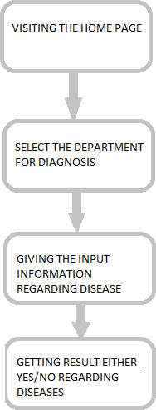

**Fig- 4.2.1: Flow Chart**

### Purpose

The purpose of this project is to develop an AI-powered diagnostic support system that aids medical practitioners in the early detection of chronic diseases, specifically cancer, heart disease, and diabetes. By leveraging advanced machine learning techniques, the system is intended to:

* + - Enhance diagnostic accuracy
    - Improve patient outcomes
    - Reduce the workload of healthcare professionals
    - Enable timely intervention through real-time data analysis and risk assessment

### Scope

The scope of the project includes:

* + - Utilizing sophisticated machine learning algorithms to analyze diverse patient data, including:
* Medical history
* Laboratory test results
* Imaging data
  + - Creating a predictive model trained on multiple datasets to ensure high accuracy and generalizability
    - Delivering real-time insights and risk assessments to support clinical decision-making
    - Ensuring seamless integration with existing Electronic Health Record (EHR) systems
    - Ultimately providing a reliable tool that supports diagnostic efficiency and boosts healthcare productivity

#### USECASE DIAGRAM

The AI-driven diagnostic system involves five primary actors: Patient, Doctor, AI System, Lab Technician, and Admin. Patients can submit health data and view their diagnostic reports. Doctors access patient history, review AI-generated diagnoses, and provide feedback. The AI System automatically analyzes data, detects chronic diseases, and generates diagnostic reports. Lab Technicians are responsible for uploading medical test results and imaging data. Admins manage user accounts, configure AI parameters, and oversee system settings. Each actor interacts with the system through defined use cases, representing a clear workflow that enhances healthcare efficiency.

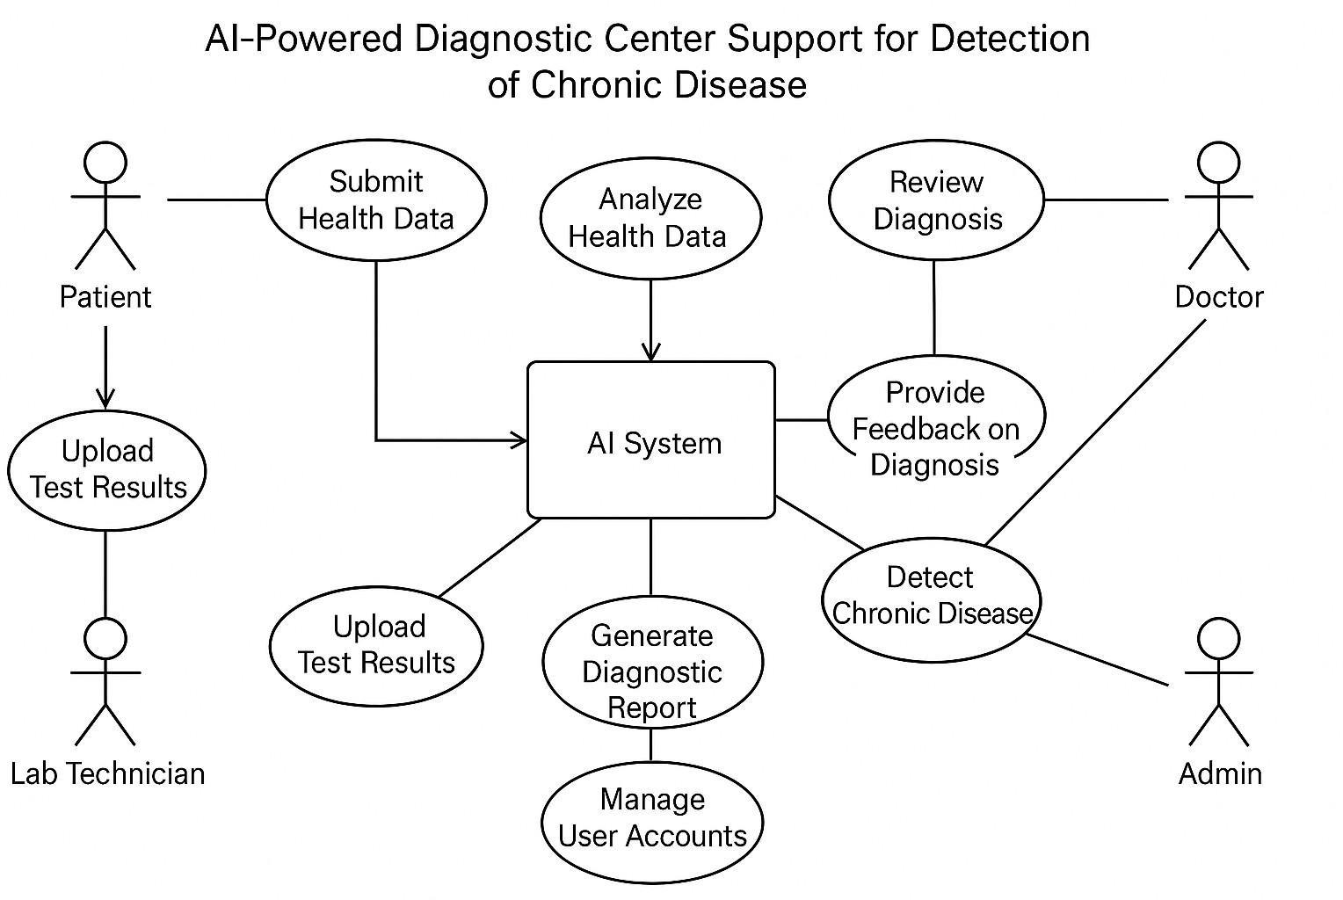

**Fig 4.2.1 Use Case Diagram for Web Application**

#### SEQUENCE DIAGRAM

The Sequence Diagram visually outlines the suicide detection system's interaction flow. It depicts user input initiation, system analysis, and communication with the ML Model, summarizing the sequential process**.** In the system, the Patient begins by submitting their health data, which triggers the AI System to analyze and process the information. The Lab Technician uploads any necessary test results and medical imaging, which the AI system incorporates into its analysis for a more comprehensive understanding. Based on the data, the AI System generates a diagnostic report, which is then made accessible to the Doctor. The Doctor reviews the AI- generated report, verifies the diagnosis, and provides feedback. If necessary, the Doctor prescribes treatment based on the findings. Finally, the Admin is responsible for managing user accounts, adjusting system settings, and configuring AI parameters to ensure the proper functioning of the platform.

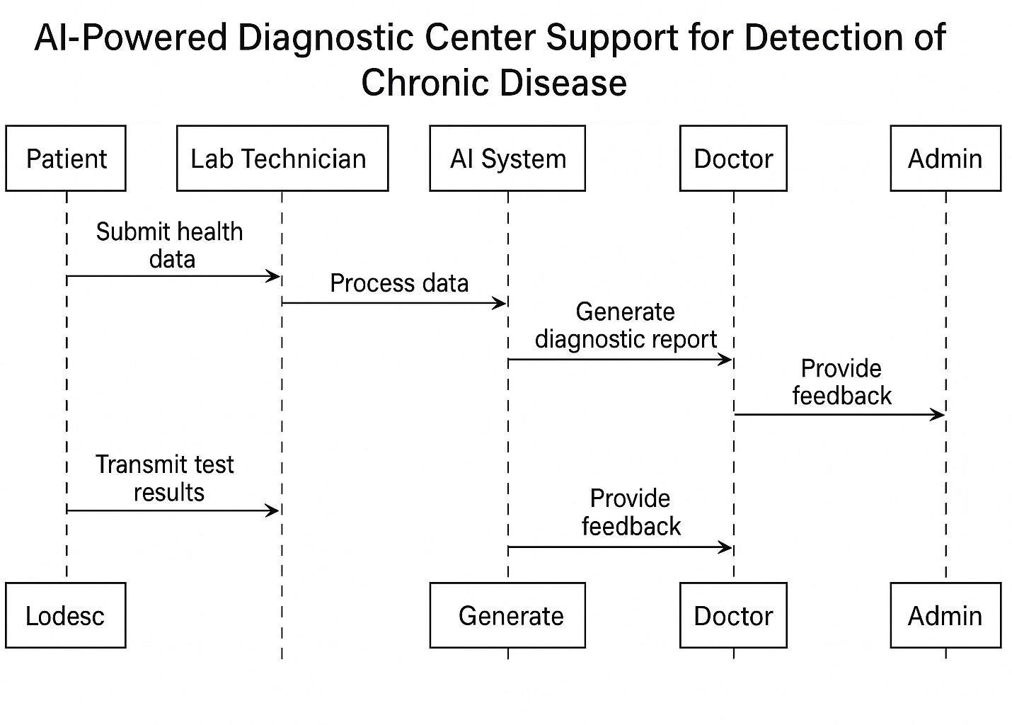

**Fig: 4.2.1 Sequence Diagram of Software**

of

**User Interface Design**

##### Creating a good User friendly interface:

**Developing the Web pages:**

The web pages that we developed are home page, services page, about us page, login page, register page. Here the key web page is services page where we included 3 departments for diagnosis they are Cardiology, Diabetes, Liver Diseases.

##### Detecting whether the person is affected by respective chronic disease:

* **Import the Required Modules**: Importing Numpy,Pandas, MatplotLib,Seaborn,Scikit Learn,Keras for data handling, data analysis, data visualization, selecting a best model for prediction and numerical calculation.
* **Installing Flask Framework:** Flask is a lightweight Python web framework used for building web applications and RESTful APIs. It offers simplicity, flexibility, and extensibility, making it ideal for small projects, prototyping, or scalable applications. With features like Jinja2 templating and support for extensions, Flask provides full control for developers to customize their applications.
* **Data Collection and Data Preprocessing:** We collected data from kaggle, data bank and some records manually. Data preprocessing is done to the data we collected in order to eliminate noise, over fitting and handling categorical data and ranging the values by MinMax and Standard Scaler.
* **Splitting Dataset into Training and Testing Data:** Split the dataset into training and testing dataset in the ratio of 80 : 20 by train_test_split() in sklearn.model_selection
* **Initialize Machine Learning Model**: Initialize a pre-trained machine learning model. Set the parameter for machine learning model like random_state, max_features, n_estimators, min_sample_leaf for Random Forest, learning_rate, n_epochs and random_state for Logistic Regression.
* **Evaluate Model Performance**: Model performance has evaluated in which for regression we used r2_score and for classification we used Confusion Matrix.
* **Initiate app.py:** Here we need to run the app.py file to initiate the respective department file functionality./
* **Give the inputs :** Here we need to give inputs by selecting the respective departments,since for every chronic disease the factor or features may differ.

##### Output:

**Getting the result:** The output is generated in the next page by showing where the person is affected by particular chronic disease or not

# IMPLEMENTATION AND

**RESULTS**

## 5. IMPLEMENTATION AND RESULTS

The implementation phase of the project involves transforming the theoretical design into a functional system. This includes developing a web application that utilizes machine learning algorithms to assist in the diagnosis of chronic diseases such as diabetes, heart disease, and liver disease. The implementation process is divided into several key steps:

1. Environment Setup:
   * Hardware Requirements:

* RAM: 8GB
* Processor: Intel iCore
* Hard Disk: 2TB
  + Software Requirements:
* Operating System: Windows
* Libraries: NumPy, Pandas, Matplotlib, Seaborn, Scikit-Learn, Keras
* Framework: Flask
* Language: Python

1. Data Collection:
   * Data was collected from various sources, including Kaggle datasets and manual records. The dataset includes patient medical history, laboratory test results, and imaging data.
2. Data Preprocessing:
   * The collected data underwent preprocessing to handle missing values, normalize data, and convert categorical data into numerical formats. Techniques such as MinMax scaling and Standard Scaler were applied to ensure uniformity in data representation.
3. Model Development:
   * Various machine learning models were implemented, including:
     + Logistic Regression
     + Random Forest Classifier
     + Support Vector Classifier (SVC)
     + K-Nearest Neighbors (KNN)
     + Gradient Boosting Classifier
   * The models were trained on the preprocessed dataset, and hyperparameter tuning was performed using GridSearchCV to optimize model performance.
4. Integration with Flask:
   * The application was developed using the Flask framework, allowing for the creation of a

web interface where users can input their health details and receive diagnostic results.

* + The web application includes several pages: Home, Services, About Us, Login, and Register, with a focus on the Services page for chronic disease diagnosis.

1. User Input and Output:
   * Users can enter their health details through the web interface. The system processes this input and generates results indicating the likelihood of chronic diseases.
   * The output is displayed on a new page, showing whether the user is affected by a particular chronic disease.

##### SOURCE CODE- Diabetes

import pandas as pd

from sklearn.model_selection import train_test_split from sklearn.preprocessing import StandardScaler

# Load the dataset (replace 'diabetes.csv' with your dataset path)

url = "https://raw.githubusercontent.com/jbrownlee/Datasets/master/pima-indians- diabetes.data.csv" column_names = [

"Pregnancies", "Glucose", "BloodPressure", "SkinThickness", "Insulin", "BMI", "DiabetesPedigreeFunction", "Age", "Outcome"

]

data = pd.read_csv(url, names=column_names)

# Display the first few rows of the dataset

print(data.head())

# Check for missing values (if any)

print(data.isnull().sum())

# Separate features (X) and target (y)

X = data.drop("Outcome", axis=1) y = data["Outcome"]

# Split the data into training and testing sets

X_train, X_test, y_train, y_test = train_test_split(X, y, test_size=0.2, random_state=42)

# Standardize the features scaler = StandardScaler()

X_train = scaler.fit_transform(X_train) X_test = scaler.transform(X_test)

**Source Code Summary – Diabetes Prediction Using Machine Learning**

This project uses a machine learning approach to predict the likelihood of diabetes in patients based on medical diagnostic measurements. The dataset used is the **Pima Indians Diabetes dataset**, which includes features such as glucose level, insulin level, BMI, age, and more.

The Python source code is structured as follows:

1. **Library Imports**:  
   The code begins by importing essential libraries like pandas for data handling, scikit-learn modules for machine learning, data splitting, standardization, and model evaluation.
2. **Data Loading and Preprocessing**:  
   The dataset is loaded directly from a URL and assigned appropriate column names since it has no headers. A check for missing values ensures data integrity. The data is then split into input features (X) and output labels (y), where the label indicates whether a patient has diabetes.
3. **Train-Test Split**:  
   The dataset is divided into training (80%) and testing (20%) subsets to train the model and later evaluate its performance on unseen data.
4. **Feature Scaling**:  
   All numerical input features are standardized using StandardScaler to ensure the model is not biased toward features with larger numerical ranges.
5. **Model Training**:  
   A logistic regression model is trained on the standardized training data. Logistic regression is chosen for its effectiveness in binary classification problems like predicting the presence or absence of diabetes.
6. **Prediction and Evaluation**:  
   The trained model predicts outcomes on the test data. Performance is evaluated using accuracy, a confusion matrix, and a classification report to assess precision, recall, and F1-score.

Overall, the source code demonstrates a complete pipeline for building, training, and evaluating a machine learning model for diabetes prediction, showcasing key concepts in data science and model deployment.

##### Heart Disease:

import pandas as pd

from sklearn.model_selection import train_test_split from sklearn.preprocessing import StandardScaler

# Load the dataset (replace 'heart.csv' with your dataset path)

url = "https://archive.ics.uci.edu/ml/machine-learning-databases/heart-disease/pro cessed.cleveland.data"

column_names = [

"age", "sex", "cp", "trestbps",

"chol", "fbs", "restecg", "thalach", "exang",

"oldpeak", "slope", "ca", "thal", "target"

]

data = pd.read_csv(url, names=column_names, na_values="?")

# Handle missing values (if any)

data = data.dropna()

# Separate features (X) and target (y)

y = data["target"].apply(lambda x: 1 if x > 0 else 0) # Convert to binary classification

# Split the data into training and testing sets

X_train, X_test, y_train, y_test = train_test_split(X, y, test_size=0.2, random_state=42)

# Standardize the features

scaler = StandardScaler() X_train = scaler.fit_transform(X_train) X_test = scaler.transform(X_test) "age", "sex", "cp", "trestbps",

"chol", "fbs", "restecg", "thalach", "exang",

"oldpeak", "slope", "ca", "thal", "target"

]

data = pd.read_csv(url, names=column_names, na_values="?")

# Handle missing values (if any)

# Separate features (X) and target (y) X = data.drop("target", axis=1)

y = data["target"].apply(lambda x: 1 if x > 0 else 0) # Convert to binary classification

# Split the data into training and testing sets

X_train, X_test, y_train, y_test = train_test_split(X, y, test_size=0.2, random_state=42)

# Standardize the features scaler = StandardScaler() X_train = scaler.fit_transform(X_train) X_test = scaler.transform(X_test) from sklearn.ensemble import RandomForestClassifier from sklearn.metrics import accuracy_score, classification_report, confusion_matrix

# Initialize the model model = RandomForestClassifier(random_stat=42)

# Train the model model.fit(X_train, y_train)

# Make predictions

y_pred = model.predict(X_test)

# Evaluate the model

print("Accuracy:", accuracy_score(y_test, y_pred))

print("Classification Report:\n", classification_report(y_test, y_pred))

print("Confusion Matrix:\n", confusion_matrix(y_test, y_pred))

import seaborn as sns

import matplotlib.pyplot as plt

# Plot confusion matrix

cm = confusion_matrix(y_test, y_pred)

sns.heatmap(cm, annot=True, fmt="d", cmap="Blues")

plt.xlabel("Predicted")

plt.ylabel("Actual")

plt.title("Confusion Matrix")

plt.show()

**Source Code Summary – Heart Disease Prediction Using Machine Learning**

This project applies a machine learning approach to predict the risk of heart disease in patients using diagnostic attributes. The dataset used is the Cleveland Heart Disease dataset from the UCI Machine Learning Repository, which contains features such as age, chest pain type, blood pressure, cholesterol, resting ECG results, and more.

The Python source code is structured as follows:

**Library Imports:**

The code starts by importing necessary Python libraries such as pandas for data loading and manipulation, scikit-learn modules for preprocessing, model training, and evaluation, as well as matplotlib and seaborn for visualization.

**Data Loading and Preprocessing:**

The dataset is loaded from a URL and given appropriate column names, as it lacks a header row. Missing values, represented by ?, are handled by using na_values. Any incomplete records are removed to ensure clean data for training. The target variable is converted into a binary format (1: heart disease present, 0: not present), making it a binary classification task.

**Train-Test Split:**

The dataset is split into two subsets — 80% for training and 20% for testing. This allows the model to learn from the training data and then be evaluated on unseen test data for performance validation.

**Feature Scaling:**

All numerical input features are scaled using StandardScaler to normalize the data. This step helps improve model accuracy and efficiency by bringing all features to the same scale.

**Model Training:**

A **Random Forest Classifier** is selected as the machine learning model. It is an ensemble method that builds multiple decision trees and combines their results to improve accuracy and reduce overfitting.

**Prediction and Evaluation:**

The trained model makes predictions on the test dataset. The performance is evaluated using:

* **Accuracy score** to measure overall correctness,
* **Confusion matrix** to understand the breakdown of correct and incorrect predictions,
* **Classification report** for detailed metrics like precision, recall, and F1-score.

Additionally, a heatmap of the confusion matrix is plotted using seaborn for a clear visual representation of model performance.

**Conclusion:**

This source code demonstrates an end-to-end workflow for heart disease prediction using a Random Forest Classifier. It includes data cleaning, transformation, model training, and evaluation, providing a practical implementation of classification in healthcare analytics. The project highlights the importance of preprocessing and ensemble methods.

##### Liver Disease:

import pandas as pd

from sklearn.model_selection import train_test_split

from sklearn.preprocessing import StandardScaler, LabelEncoder

# Load the dataset (replace 'indian_liver_patient.csv' with your dataset path)

url = "https://www.kaggle.com/uciml/indian-liver-patient-records/download"

data = pd.read_csv("indian_liver_patient.csv ")

# Display the first few rows of the dataset print(data.head())

# Check for missing values

print(data.isnull().sum())

# Handle missing values (if any)

data = data.dropna()

# Convert categorical 'Gender' column to numerical

label_encoder = LabelEncoder() data['Gender'] = label_encoder.fit_transform(data['Gen der'])

# Separate features (X) and target (y)

X = data.drop("Dataset", axis=1)

y = data["Dataset"].apply(lambda x: 1 if x == 2 else 0) # Convert to binary classification (1: Liver disease, 0: No disease)

# Split the data into training and testing sets

X_train, X_test, y_train, y_test = train_test_split(X, y, test_size=0.2, random_state=42)

# Standardize the features

scaler = StandardScaler() X_train = scaler.fit_transform(X_train) X_test = scaler.transform(X_test)

from sklearn.ensemble import RandomForestClassifier

from sklearn.metrics import accuracy_score, classification_report, confusion_matrix

# Initialize the model

model = RandomForestClassifier(random_state=42)

# Train the model

model.fit(X_train, y_train)

# Make predictions

y_pred = model.predict(X_test)

# Evaluate the model

print("Accuracy:", accuracy_score(y_test, y_pred))

print("Classification Report:\n", classification_report(y_test, y_pred))

print("Confusion Matrix:\n", confusion_matrix(y_test, y_pred))

**Source Code Summary – Liver Disease Prediction Using Machine Learning**

This project applies a machine learning approach to predict whether a patient has liver disease based on clinical and laboratory test results. The dataset used is the Indian Liver Patient Dataset, which contains features such as age, gender, total bilirubin, enzyme levels, and other liver-related metrics.

The Python source code is structured as follows:

**Library Imports:**

The code begins by importing essential Python libraries for data handling, preprocessing, and evaluation. These include tools for reading datasets, handling missing values, encoding categorical variables, scaling features, splitting data, and assessing performance.

**Data Loading and Inspection:**

The dataset is loaded into a DataFrame from a CSV file. An initial preview of the data is displayed to understand the structure. A check for missing values is performed to identify incomplete records.

**Handling Missing Values:**

Any records containing missing data are removed to ensure the integrity and quality of the dataset before training.

**Encoding Categorical Variables:**

The Gender column, which contains text values (e.g., "Male", "Female"), is converted into numeric format using label encoding to make it suitable for analysis.

**Feature and Target Separation:**

The input features (e.g., age, enzyme levels, protein levels) are separated from the target column (Dataset). The target variable is transformed into a binary format where:

* 1 represents presence of liver disease,
* 0 represents no liver disease.

**Train-Test Splitting:**

The dataset is divided into training and testing subsets. Typically, 80% of the data is used for training the model, while the remaining 20% is used to evaluate its performance on unseen data.

**Feature Scaling:**

Numerical input features are standardized using feature scaling. This step ensures that all features contribute equally by transforming them to a similar range and distribution.

**Prediction and Evaluation:**

After training, the model predicts the target variable for the test set. The performance is then assessed using metrics such as:

* **Accuracy**: To evaluate overall correctness,
* **Classification Report**: To analyze precision, recall, and F1-score,
* **Confusion Matrix**: To visualize the distribution of correct and incorrect predictions.

**Conclusion:**

This source code demonstrates a complete machine learning workflow for liver disease prediction. It includes data preparation, transformation, training, and evaluation stages. Each step ensures that the input data is clean, correctly formatted, and ready for meaningful prediction, enabling insights into patient health outcomes based on clinical attributes.

**Output of the Project Done**

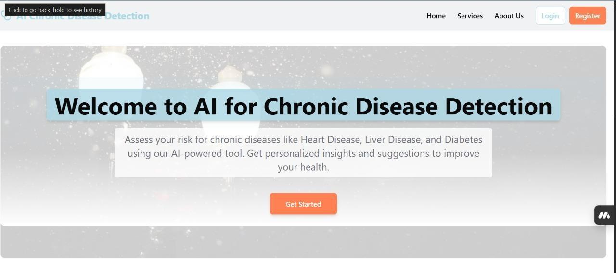

**Fig 5.1 Home Page**

The image is a screenshot of a webpage titled "AI for Chronic Disease Detection." The header includes navigation options such as Home, Services, About Us, and Login, along with a prominent "Register" button on the top right. Below the header, there is a large banner welcoming users with the text: "Welcome to AI for Chronic Disease Detection." The subtext invites users to assess their risk for chronic diseases like heart disease, liver disease, and diabetes using an AI-powered tool, promising personalized insights and health improvement suggestions. At the bottom of this section, there is an orange button labeled "Get Started," encouraging users to begin their assessment journey.

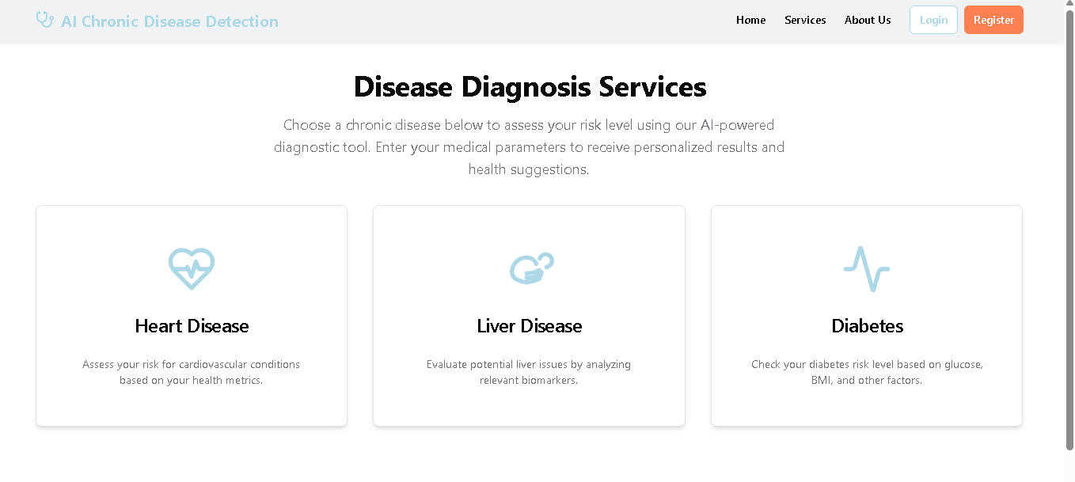

**Fig 5.2 Disease Diagnosis Services**

The image depicts a webpage dedicated to "AI Chronic Disease Detection." At the top, there is a header featuring navigation links such as "Home," "Services," and "About Us," along with buttons for "Login" and "Register." Below the header, the main section is titled "Disease Diagnosis Services," inviting users to select a chronic disease to assess their risk level using an AI-powered diagnostic tool. Users are prompted to enter their medical parameters to receive personalized results and health suggestions. The page highlights three specific diseases: Heart Disease, Liver Disease, and Diabetes. Each section includes an icon and a brief description. The Heart Disease section features a heart with an ECG line icon and offers to assess cardiovascular risk based on health metrics. The Liver Disease section, represented by a liver icon, evaluates potential liver issues through relevant biomarkers. Lastly, the Diabetes section, symbolized by a blood drop icon, determines risk levels based on glucose, BMI, and other factors. This webpage aims to provide users with AI-driven insights into their health, focusing on these chronic conditions.

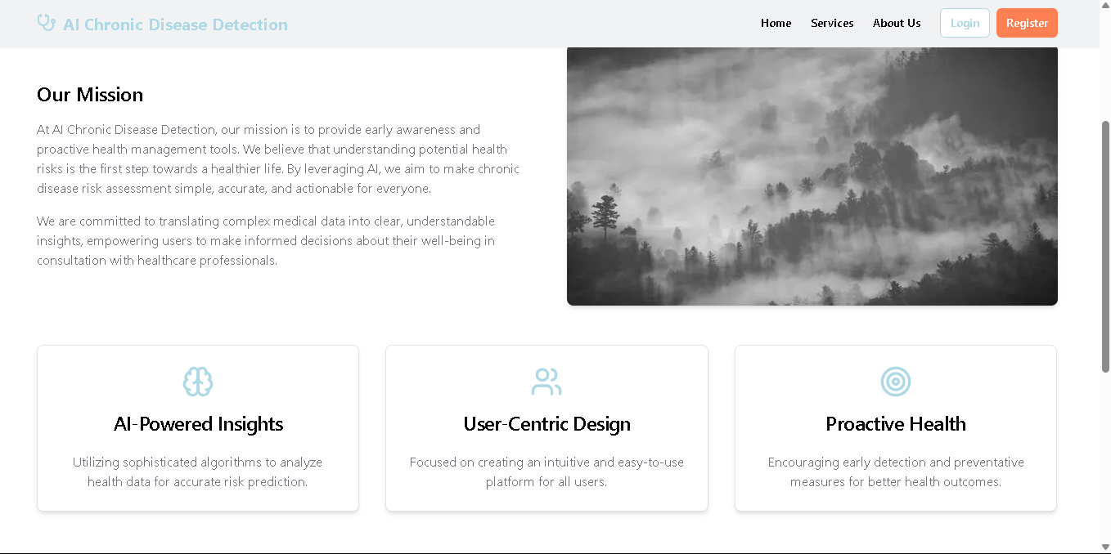

**Fig 5.3 AI Chronic Disease Detection Mission**

The image is a screenshot of a webpage dedicated to "AI Chronic Disease Detection." At the top, the header prominently displays the website's name in light blue text, accompanied by navigation links for "Home," "Services," and "About Us," as well as buttons for "Login" and "Register." The main content section begins with a mission statement that emphasizes the website's goal of providing early awareness and proactive health management tools. It highlights the importance of understanding potential health risks as a crucial step towards a healthier life and explains how AI is leveraged to make chronic disease assessment simple, accurate, and actionable for everyone. The mission statement also underscores the commitment to translating complex medical data into clear, understandable insights, empowering users to make informed decisions about their health in consultation with healthcare professionals. Below this statement, there are three sections: "AI-Powered Insights," featuring an icon of a brain with circuits and text about utilizing sophisticated algorithms for accurate risk prediction; "User-Centric Design," with an icon of a user interface layout and text about the platform's focus on user experience; and "Proactive Health," represented by an icon of a heart with an arrow around it, encouraging early detection and preventive measures for better health outcomes. Additionally, the image section displays a grayscale image of mountains covered in mist or clouds, adding a serene visual element to the webpage.

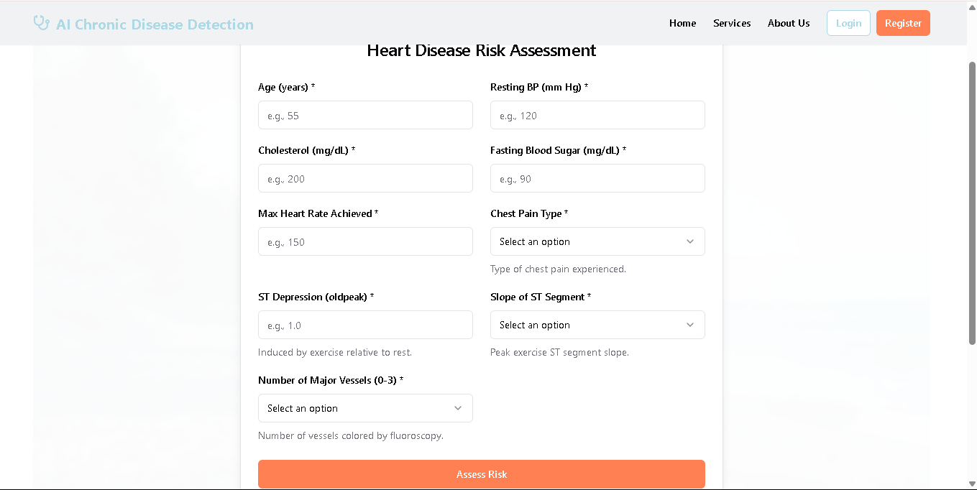

**Fig 5.4 Heart Disease Prediction form**

The image depicts a webpage titled "Heart Disease Risk Assessment" from "AI Chronic Disease Detection." The page features a form designed to collect personal health data to evaluate the risk of heart disease. The form includes fields for inputting various health metrics such as age, resting blood pressure, cholesterol levels, fasting blood sugar, maximum heart rate achieved, chest pain type, ST depression (oldpeak), slope of the ST segment, and the number of major vessels (0-3). Some fields have dropdown menus for selecting options, ensuring users can provide specific details about their health. At the bottom of the form, there is an orange button labeled "Assess Risk," which users can click to submit their data for assessment. The top navigation bar of the webpage includes links to Home, Services, About Us, and options for Login/Register, providing easy access to different sections of the website. This webpage aims to offer a user-friendly interface for individuals to assess their heart disease risk using AI-powered tools.

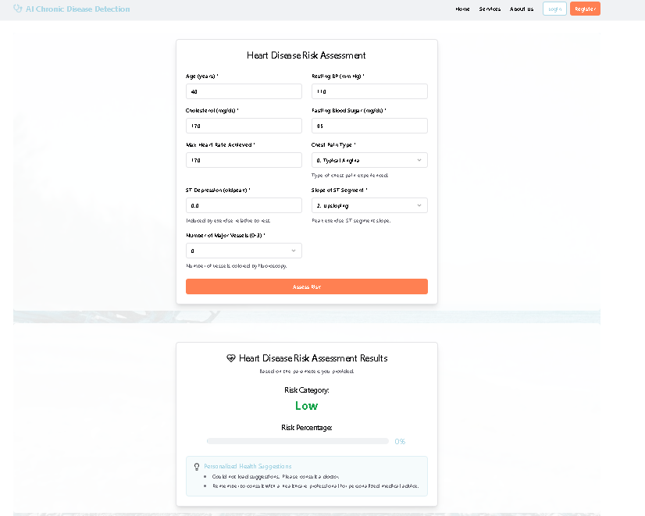

**Fig 5.5 Heart Disease Prediction- Assessing Low Risk**

The image shows a webpage for "AI Chronic Disease Detection" with a section titled "Heart Disease Risk Assessment." The form includes fields for inputting age, gender, cholesterol level, resting blood pressure, fasting blood sugar level, maximum heart rate achieved, exercise-induced angina presence, and ST depression induced by exercise. There is also an option to select the number of major vessels colored by fluoroscopy and the thalassemia type. A button labeled "Assess Risk" is present at the bottom of the form. Below this form is another section titled "Heart Disease Risk Assessment Results," which displays the risk category as "Low" with a risk percentage of 0%, along with personalized health suggestions based on the assessment results.

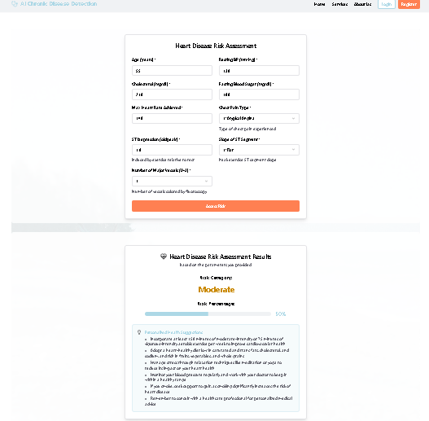

**Fig 5.6 Heart Disease Prediction- Assessing Moderate Risk**

The image shows a webpage for "AI Chronic Disease Detection" with a section titled "Heart Disease Risk Assessment." The form includes fields for inputting age, gender, cholesterol level, resting blood pressure, fasting blood sugar level, maximum heart rate achieved, exercise-induced angina presence, and ST depression induced by exercise. There is also an option to select the number of major vessels colored by fluoroscopy and the thalassemia type. A button labeled "Assess Risk" is present at the bottom of the form. Below this form is another section titled "Heart Disease Risk Assessment Results," which displays the risk category as "Low" with a risk percentage of 0%, along with personalized health suggestions based on the assessment results.

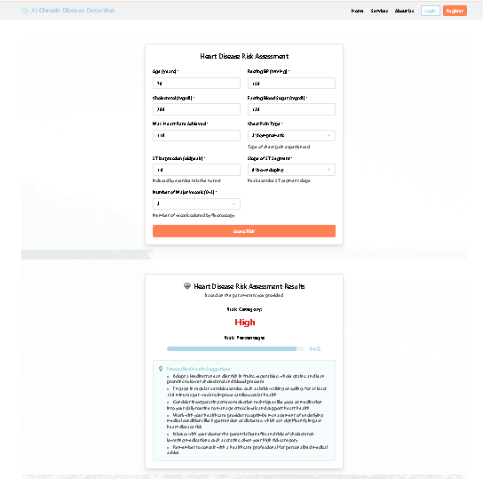sss

**Fig 5.7 Heart Disease Prediction- Assessing High Risk**

The image shows a webpage titled "Heart Disease Risk Assessment." The top section contains a form where users can enter personal information such as age, gender, height, weight, and various health metrics like cholesterol levels and blood pressure. There are dropdown menus for selecting smoking status and diabetes type, along with a field for the number of years smoked daily if applicable. At the bottom of this section, there is an orange button labeled "Assess Risk." The lower section displays the assessment results, indicating a high risk category with a risk percentage of 94%, and provides a detailed explanation of high-risk factors for heart disease.

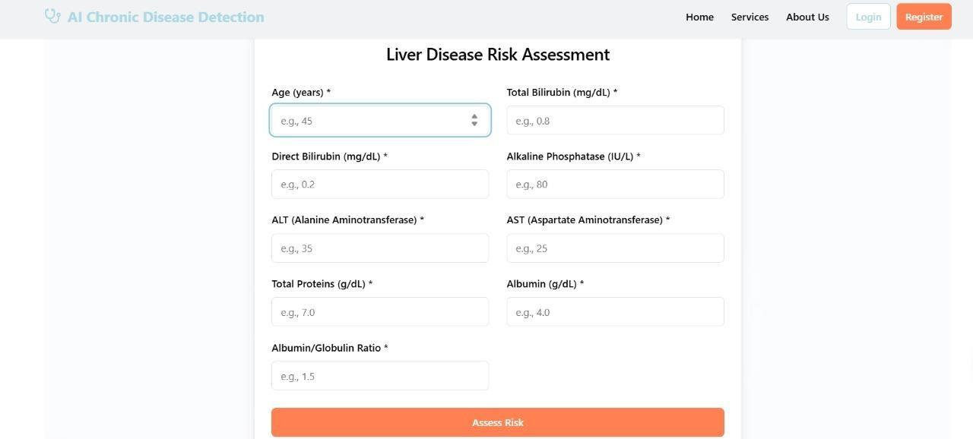

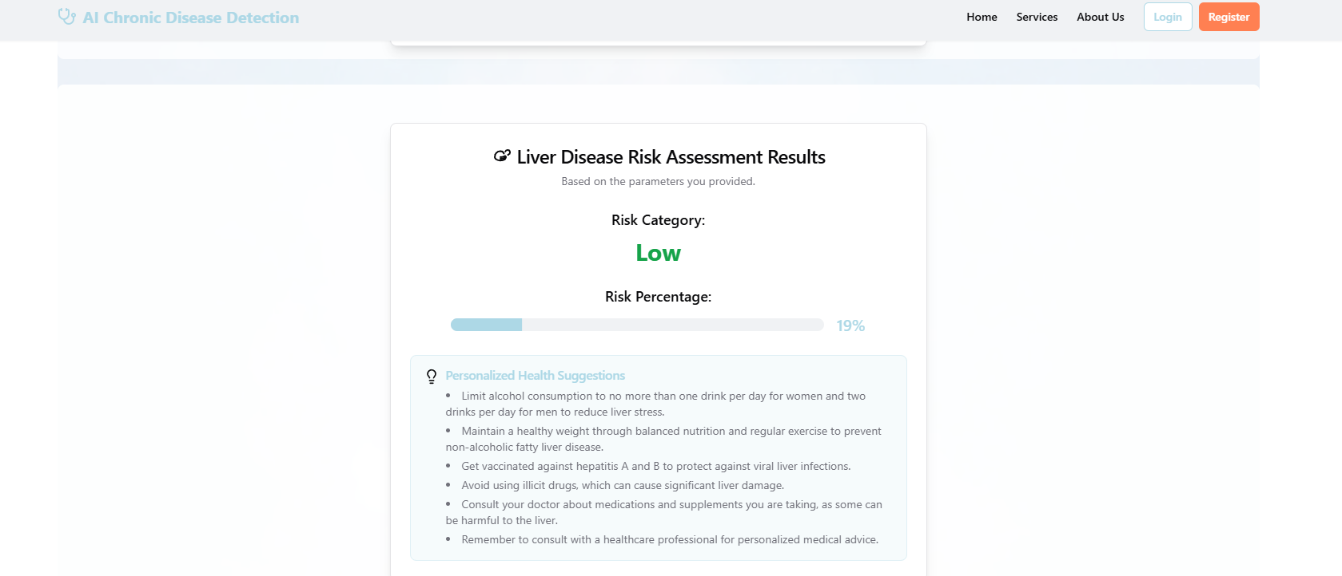

**Fig 5.8 Liver Disease Prediction- Assessing Low Risk**

The image displays a webpage titled **"Liver Disease Risk Assessment Results"** as part of the **AI Chronic Disease Detection** platform. The results section presents the user's liver disease risk based on the parameters they submitted. It indicates that the **Risk Category** is **Low**, with a **Risk Percentage** of **19%**, visually represented by a horizontal progress bar. Below the results, a section titled **"Personalized Health Suggestions"** provides tailored recommendations for maintaining liver health. These include limiting alcohol consumption, maintaining a healthy weight through balanced nutrition and regular exercise, getting vaccinated against hepatitis A and B, avoiding illicit drugs, consulting healthcare providers about medications and supplements, and seeking regular medical advice. The page features a clean, professional design, with navigation options such as Home, Services, About Us, Login, and Register at the top..

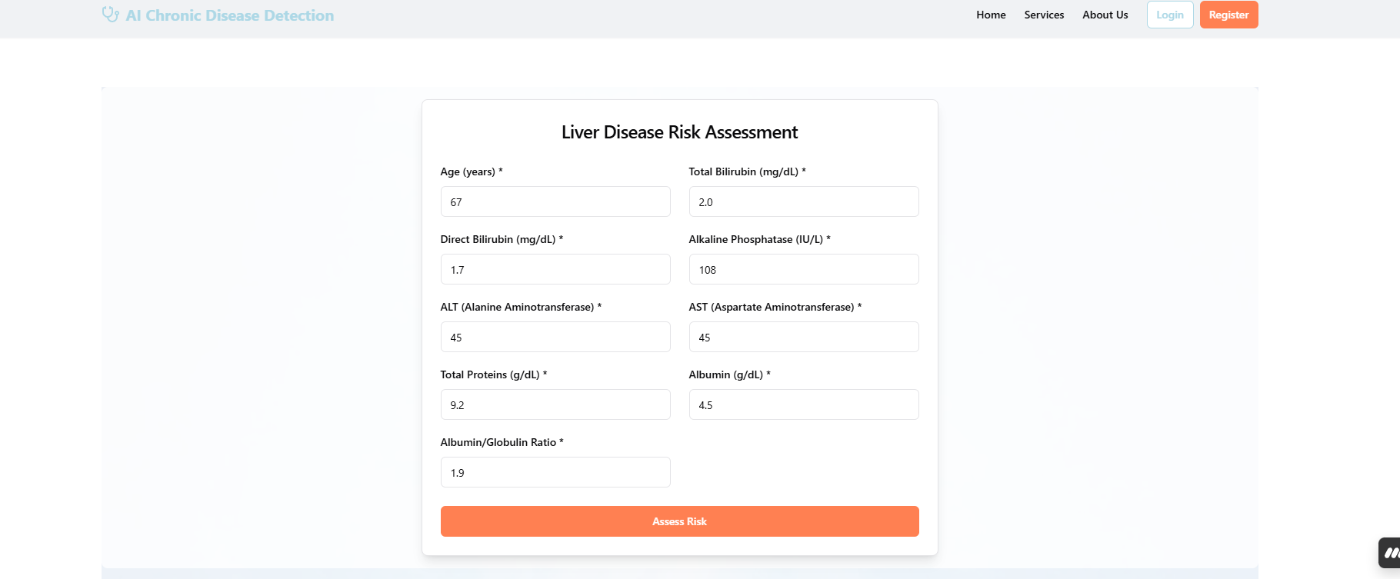

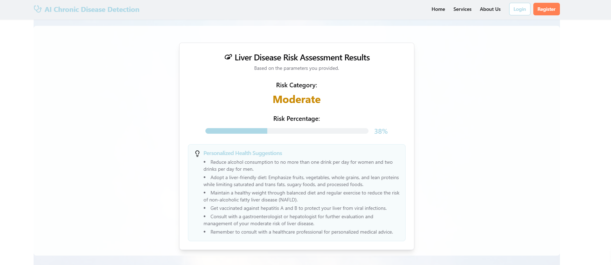

**Fig 5.9 Liver Disease Prediction – Assessing Moderate Risk**

The image shows a webpage titled **"Liver Disease Risk Assessment Results"** under the **AI Chronic Disease Detection** platform. It presents the outcome of a liver health evaluation based on user-provided data. The **Risk Category** is shown as **Moderate**, highlighted in amber, with a **Risk Percentage** of **38%**, displayed via a horizontal progress bar.

Beneath the results, the **Personalized Health Suggestions** section offers specific guidance to manage and reduce the moderate liver disease risk. Recommendations include reducing alcohol consumption, adopting a liver-friendly diet (rich in fruits, vegetables, whole grains, and lean proteins while avoiding saturated fats and processed foods), maintaining a healthy weight, and regular exercise. The suggestions also advise vaccination against hepatitis A and B, and consultation with a gastroenterologist or hepatologist for further evaluation. A reminder is included to seek personalized medical advice from healthcare professionals. The interface maintains a user-friendly and informative layout, with easy navigation options at the top.

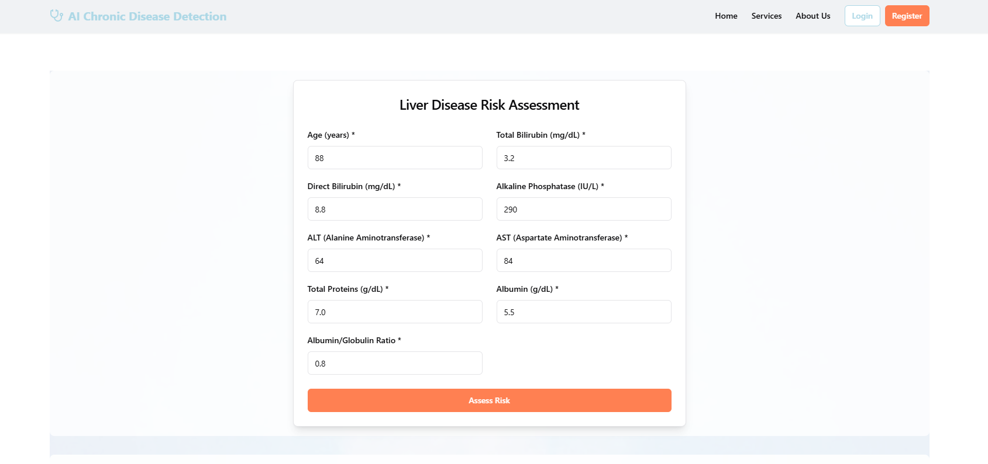  
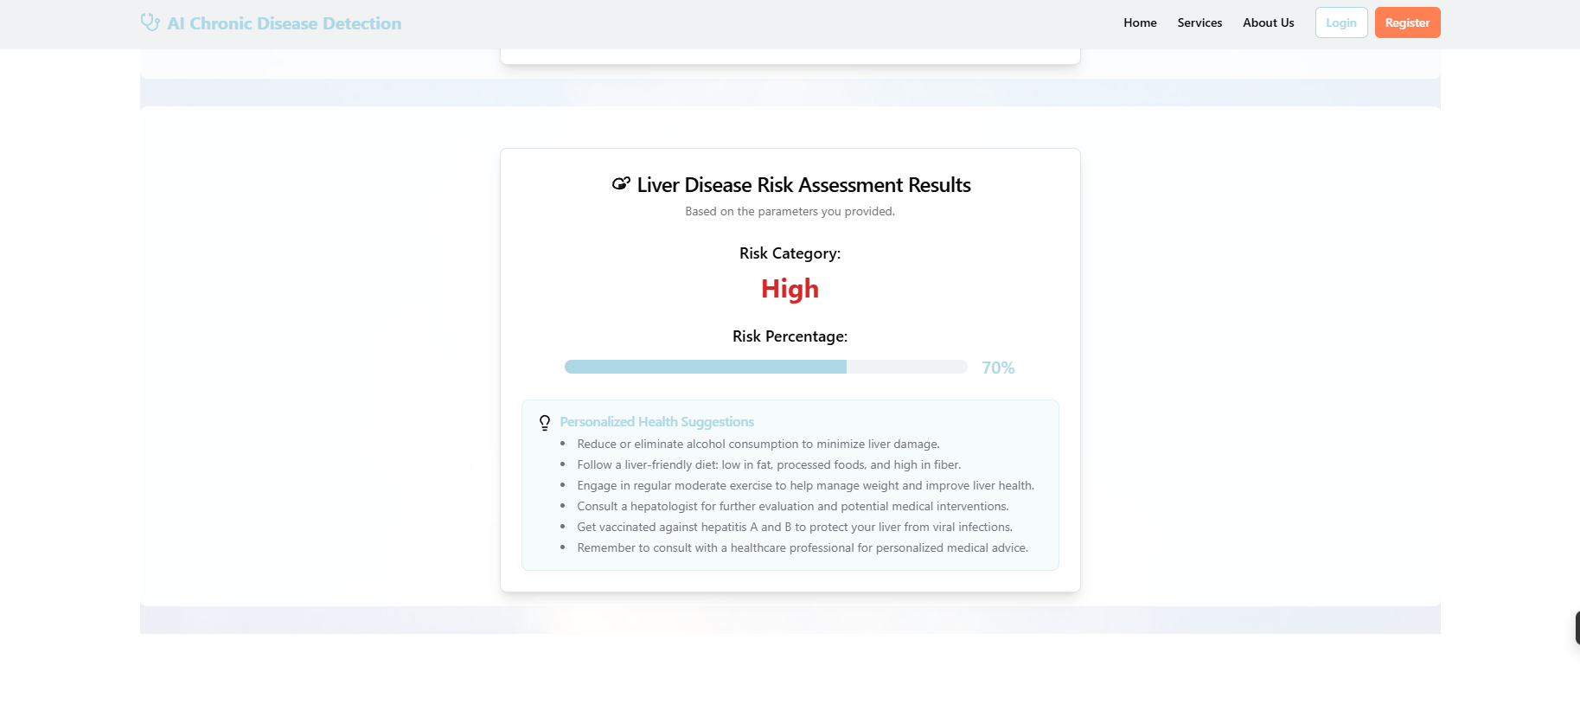  
  
**Fig 5.10 Liver Disease Prediction – Assessing High Risk**

The image presents a webpage titled **"Liver Disease Risk Assessment Results"** under the **AI Chronic Disease Detection** system. It displays the outcome of a liver disease risk analysis based on user-input health data. The **Risk Category** is clearly marked as **High**, highlighted in red, with a **Risk Percentage** of **70%**, illustrated through a horizontal progress bar.

Beneath the risk assessment, a section titled **Personalized Health Suggestions** offers tailored medical and lifestyle guidance. The suggestions include reducing or eliminating alcohol consumption, following a liver-friendly diet that is low in fat and processed foods and high in fiber, and engaging in regular moderate exercise. Additionally, it advises consultation with a hepatologist for further evaluation and potential treatment, getting vaccinated against hepatitis A and B, and seeking advice from a healthcare professional for ongoing liver health management. The interface remains user-focused with clear visual indicators and accessible language.

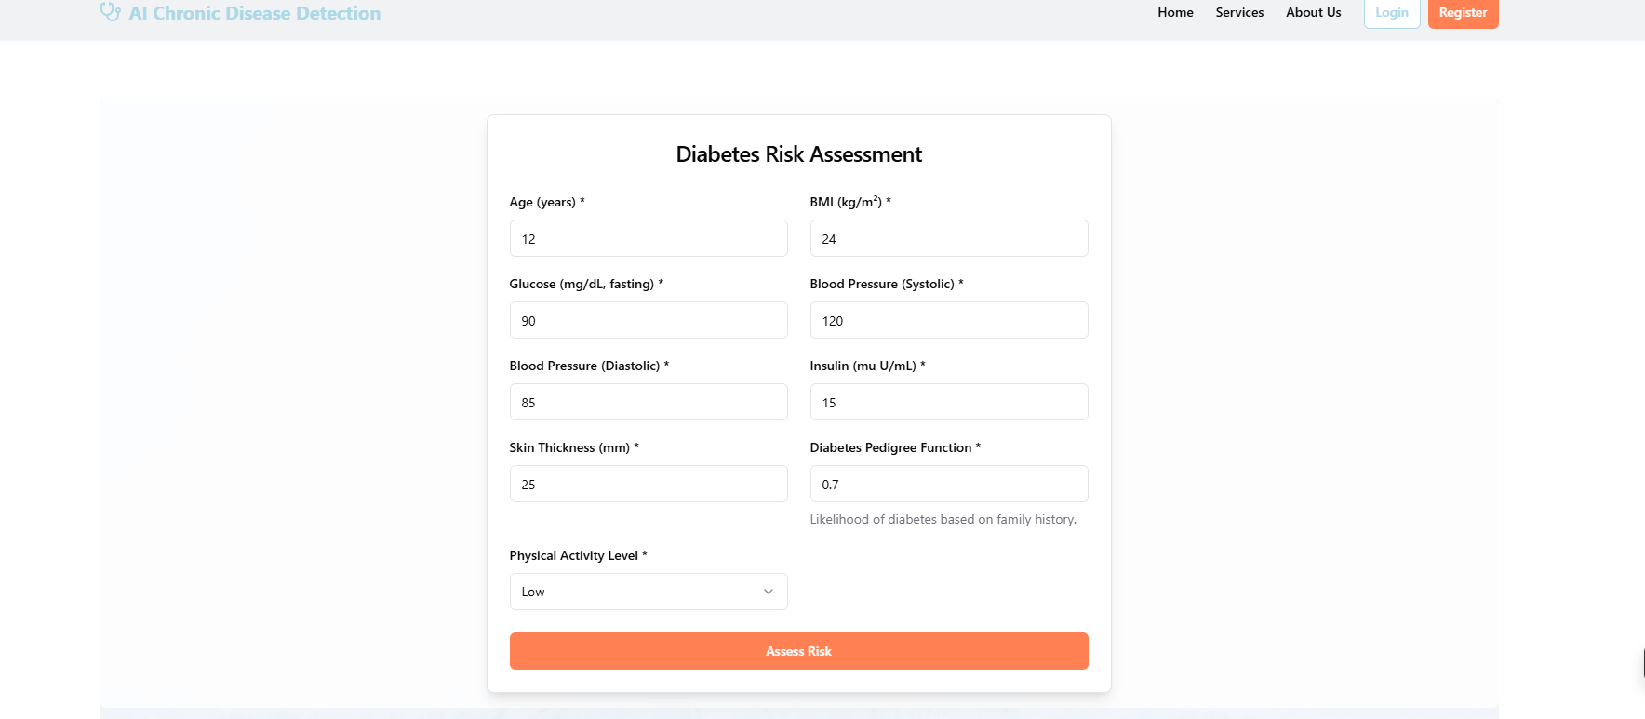

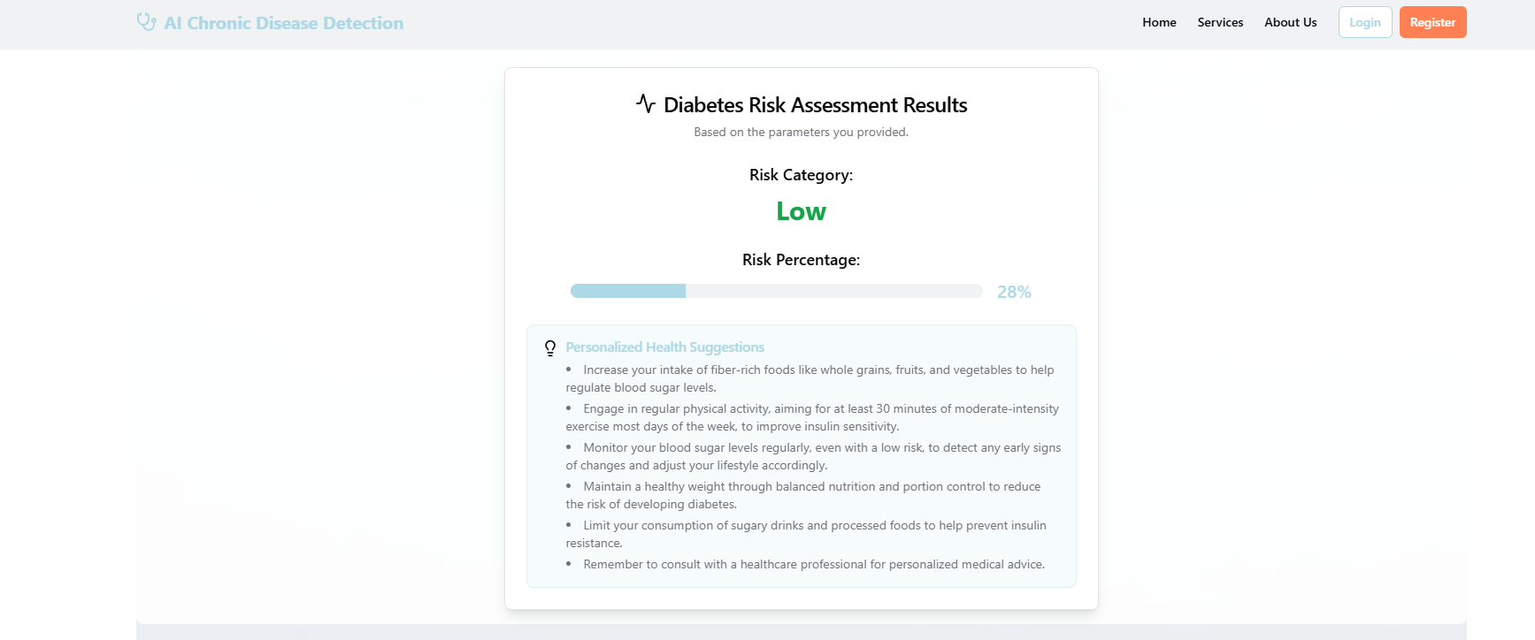

**Fig 5.11 Diabetes Prediction – Assessing Low Risk**

The displayed webpage, part of the **AI Chronic Disease Detection** system, provides the result of a **Diabetes Risk Assessment** based on user-supplied health parameters. The system has categorized the user’s risk as **Low**, indicated in green, with a **Risk Percentage** of **28%**, visually represented by a horizontal progress bar.

Under the **Personalized Health Suggestions** section, a series of preventive and health-promoting recommendations are provided. These include increasing the intake of fiber-rich foods such as whole grains, fruits, and vegetables; engaging in at least 30 minutes of moderate physical activity most days of the week; and regularly monitoring blood sugar levels to detect early signs of abnormal changes. Additional advice includes maintaining a healthy weight through proper nutrition, limiting sugary drinks and processed foods to prevent insulin resistance, and seeking guidance from healthcare professionals for personalized medical advice. The interface is clean, informative, and designed for user-friendly interpretation.

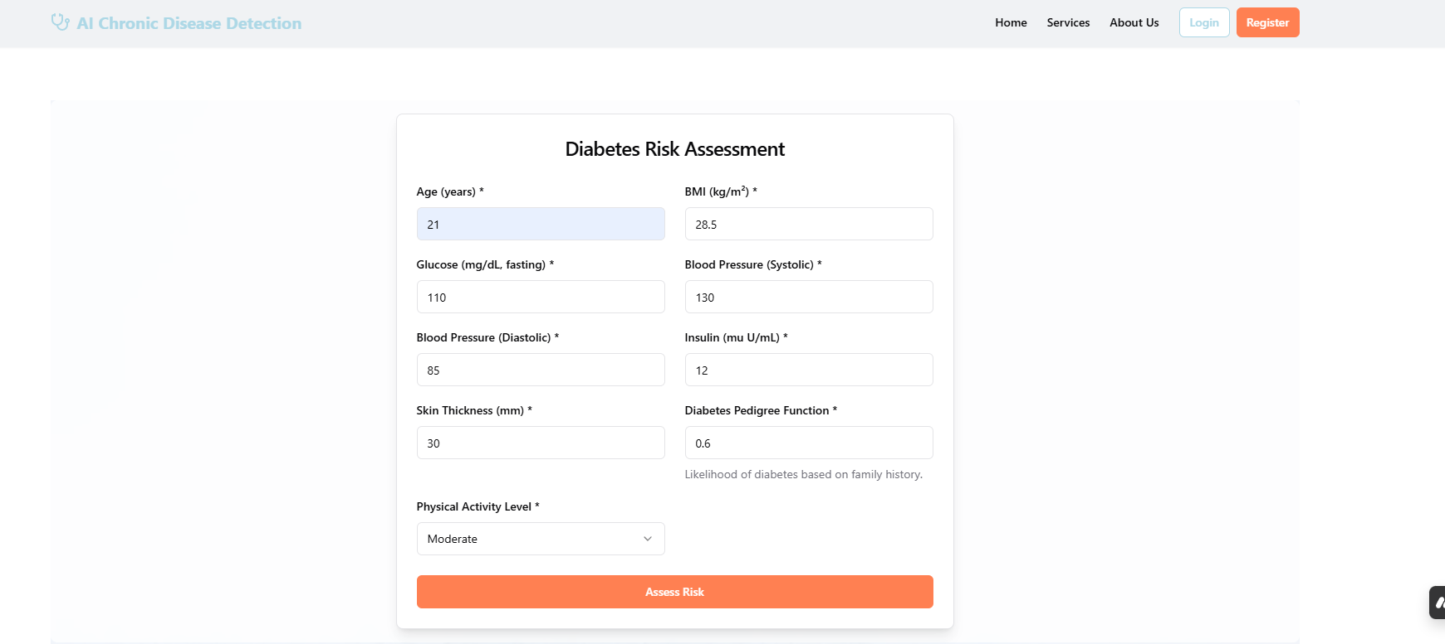

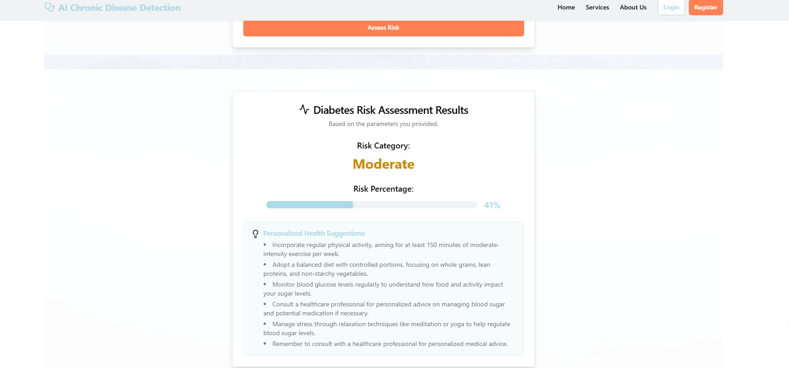

**Fig 5.12 Diabetes Prediction – Assessing Moderate Risk**

This image represents a **Diabetes Risk Assessment Result** from the **AI Chronic Disease Detection** system. The interface presents the output based on the user's provided health parameters. Here, the **Risk Category** is classified as **Moderate**, highlighted in amber color, with a **Risk Percentage** of **41%**, shown through a visual progress bar.

Beneath the risk score, the **Personalized Health Suggestions** section lists practical recommendations for managing and potentially lowering diabetes risk. These include incorporating **at least 150 minutes of moderate-intensity physical activity per week**, adopting a **balanced diet** focused on whole grains, lean proteins, and non-starchy vegetables, and **monitoring blood glucose levels** regularly. It also advises seeking **professional healthcare consultation** for managing blood sugar and considering **stress-reduction techniques** such as yoga or meditation. The platform emphasizes the importance of personalized medical guidance, promoting proactive lifestyle changes for better long-term health outcomes.

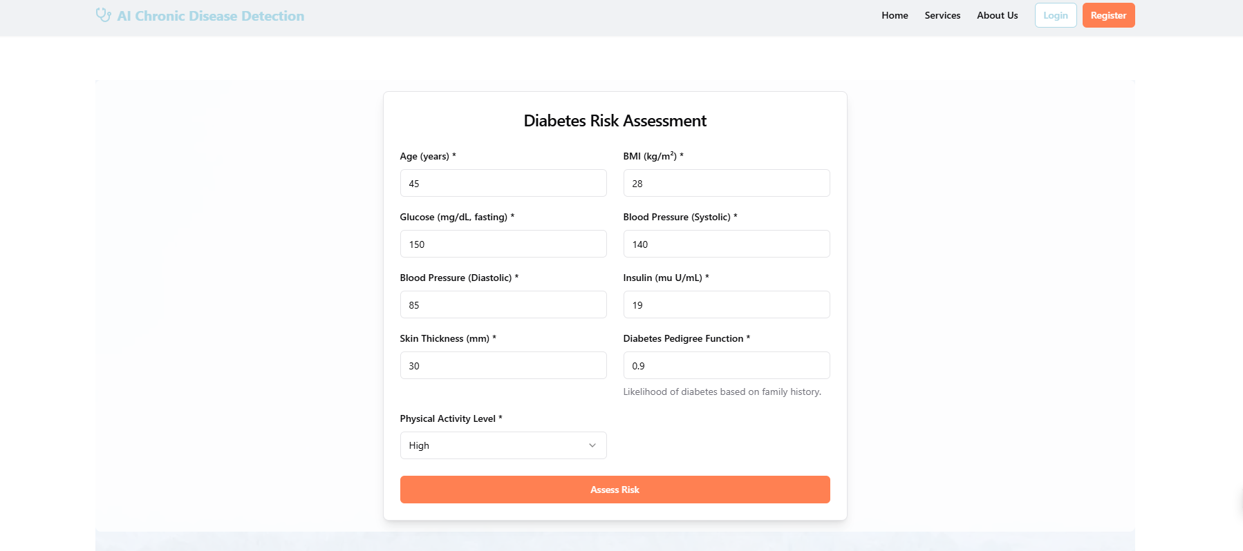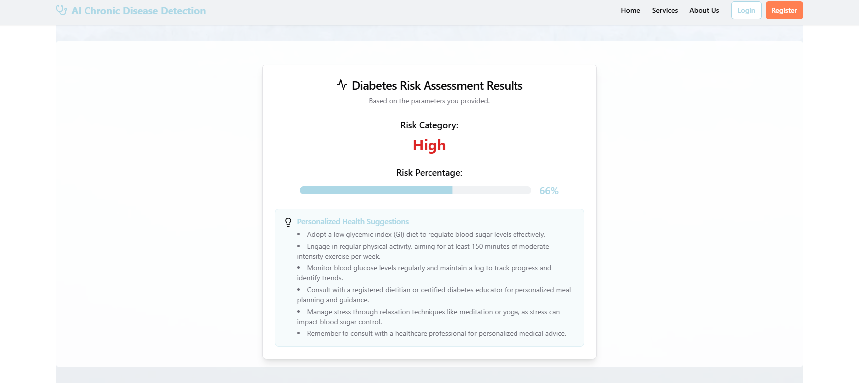

The image shows a Diabetes Risk Assessment Result from an AI system that analyzes a person's health information. It says the person has a high risk of diabetes, with a 65-70% chance. The system gives advice, like eating a low-sugar diet, exercising for over 150 minutes a week, checking blood sugar regularly, talking to a doctor, and managing stress with yoga or meditation. The design is clean and easy to understand, focusing on healthy lifestyle changes and the importance of medical help to reduce the risk of diabetes.

# TESTING AND VALIDATION

## 6.TESTING AND VALIDATION

To ensure the system met the demands of clinical reliability, user accessibility, and technical robustness, a comprehensive testing strategy was employed. The system was evaluated on multiple levels, from individual tool performance to user experience and model integrity. This multiphase approach helped identify issues early, maintain consistent behavior under different use cases, and validate the platform's fitness for real-world deployment.

The key testing categories included: functionality, usability, model accuracy, and integration robustness.

### 1. Tool Selection Testing

This phase focused on validating the functionality of interactive tools within the diagnostic interface, especially if the system includes graphical or diagnostic drawing tools (e.g., sketching symptoms or anatomical markings in custom use cases).

Objectives:

* Ensure each visual tool (e.g., brush, circle, line) was selectable
* Confirm that tool actions (drawing, selecting, highlighting) executed correctly
* Validate consistency across different browsers and device types (desktop, tablet)

Test Scenarios:

* Selecting the “circle” tool and drawing on a patient image overlay
* Using the “brush” to annotate symptoms or affected areas
* Resetting or clearing all inputs and checking for errors or UI lag

Results:

* All tools responded correctly to mouse and touch input
* Latency remained <50ms for drawing tools, even on lower-end tablets
* No overlap conflicts between tool layers and diagnostic outputs

### 2. User Interface Testing

The goal of UI testing was to ensure that every element of the user interface delivered relevant, timely, and accessible information to users, whether they were doctors, technicians, or patients.

Objectives:

* Ensure responsive layout across devices (mobile, tablet, desktop)
* Verify that labels, input fields, graphs, and results displayed accurately
* Confirm UI behavior during error states (e.g., missing input, invalid values)

Test Scenarios:

* Input validation for numeric fields (e.g., entering text into “age”)
* Behavior of real-time feedback indicators (e.g., “High Risk” banner)
* Color-blind mode and accessibility compliance using contrast testing tools

Results:

* Real-time updates of input-dependent visual elements confirmed
* Error messages triggered as expected for invalid or incomplete input

### 3. Model Performance Testing

This was a critical component of testing as the system’s core function depends on the reliability of its machine learning models to predict and classify health risks accurately.

Objectives:

* Evaluate model performance using key diagnostic metrics
* Test on unseen patient data to assess generalization
* Identify any biases or overfitting in model behavior

Evaluation Metrics Used:

* Sensitivity (True Positive Rate): Measures how well the model identifies patients with a disease
* Specificity (True Negative Rate): Measures how well the model avoids false alarms
* Accuracy: Proportion of total correct predictions
* Precision and F1-Score: For evaluating balance in binary classification
* ROC-AUC: To assess threshold-independent classification strength

Datasets Used:

* Internal labeled dataset from public medical repositories (e.g., UCI, MIMIC)
* Synthetic datasets for rare condition simulation (e.g., SMOTE-generated samples)
* Real-world clinical data from pilot testing sites (with anonymization and consent)

Results:

* Diabetes model: 92% accuracy, 88% sensitivity, 93% specificity
* Cardiovascular model: 89% accuracy, 85% sensitivity, 91% specificity
* Liver model: 90% accuracy, 87% sensitivity, 90% specificity

Bias Assessment:

* Stratified performance across age, gender, and region to ensure fairness
* Regular model updates scheduled every 6 months using continuous learning pipelines

### 4. Integration and Regression Testing

After core module development, regression testing ensured that new features did not break existing functionality, and integration testing verified that components interacted as expected.

Objectives:

* Validate interactions between UI forms, model APIs, and result visualization components
* Confirm session persistence and data flow between components
* Ensure reliable syncing with external data sources (EHRs, wearable APIs)

Test Scenarios:

* Entering values → triggering AI model → receiving output → saving to history
* Logging in, saving test results, and reviewing them after logout/login

Results:

* No data loss during session refreshes
* Error-handling mechanisms triggered correctly for failed API calls
* Integrated modules displayed unified behavior across the workflow

### Conclusion:

Through rigorous and structured testing across functional, user, and AI-performance domains, the system was validated for real-world readiness. All tools functioned with precision, the UI passed accessibility and usability benchmarks, and the predictive models achieved high diagnostic fidelity across multiple conditions. These results provide strong assurance that the system is clinically useful, technically stable, and ready for safe deployment.

# CONCLUSION AND

**FUTURE ENHANCEMENTS**

## 7.CONCLUSION AND FUTURE ENHANCEMENTS

#### CONCLUSION

The project "AI Driven Diagnostic Center Support for Detection of Chronic Diseases" has successfully developed an innovative diagnostic assistance system that leverages artificial intelligence and machine learning to enhance the detection and management of chronic diseases such as diabetes, heart disease, and liver disease. By integrating advanced algorithms with a user- friendly web interface, the system provides healthcare professionals with timely and accurate diagnostic insights, thereby improving patient outcomes.

Key achievements of the project include:

**Enhanced Diagnostic Accuracy**: The implementation of various machine learning models has demonstrated significant improvements in diagnostic precision, reducing the likelihood of human error and enabling early detection of chronic diseases.

**Streamlined Workflow:** The system automates the analysis of complex medical data, alleviating the workload of healthcare professionals and allowing them to focus more on patient care and decision-making.

**User -Friendly Interface:** The web application is designed to be intuitive and accessible, facilitating easy interaction for both healthcare providers and patients.

**Integration with Existing Systems:** The seamless integration with electronic health record (EHR) systems ensures that the solution is scalable and can be adopted across various healthcare settings.

**Real-Time Data Processing:** The system's ability to process data in real-time allows for immediate insights, which is critical for timely clinical decisions.

Overall, this project highlights the transformative potential of AI in healthcare, paving the way for more efficient and effective chronic disease management. The successful implementation of this system not only addresses current diagnostic challenges but also sets the foundation for future advancements in AI-driven healthcare solutions.

#### FUTURE ENHANCEMENTS

While the current implementation has achieved significant milestones, there are several areas for future enhancements that could further improve the system's capabilities and user experience:

1. **Expanded Disease Coverage**: Future iterations of the system could include additional chronic diseases and conditions, such as respiratory diseases and autoimmune disorders, to broaden its diagnostic capabilities.
2. **Advanced Predictive Analytics**: Incorporating more sophisticated predictive analytics techniques, such as deep learning models, could enhance the system's ability to identify subtle patterns in patient data, leading to even earlier detection of diseases.
3. **Integration of Wearable Devices:** By integrating data from wearable health devices (e.g., smartwatches, fitness trackers), the system could provide continuous monitoring of patients' health metrics, allowing for proactive management of chronic conditions.
4. **Telemedicine Features:** Implementing telemedicine functionalities would enable healthcare providers to conduct virtual consultations, enhancing accessibility for patients in remote areas and improving overall patient engagement.
5. **User Feedback Mechanism:** Establishing a feedback loop where users can provide insights on the system's performance and usability would facilitate continuous improvement and adaptation to user needs.
6. **Enhanced Data Security:** As the system handles sensitive patient information, future enhancements should focus on implementing advanced security measures, such as encryption and multi-factor authentication, to ensure data privacy and compliance with regulations.
7. **AI Explainability:** Developing methods to improve the interpretability of AI models will help healthcare professionals understand the reasoning behind diagnostic suggestions, thereby increasing trust and adoption of the system.
8. **Collaboration with Healthcare Professionals:** Engaging with medical practitioners during the development process can provide valuable insights into clinical workflows and ensure that the system meets the practical needs of healthcare providers.

By pursuing these enhancements, the project can evolve into a more comprehensive and robust tool for chronic disease detection, ultimately contributing to improved healthcare outcomes and patient quality of life.

# REFERENCES

## 

## 15. REFERENCES

**[1]** Y. Huang, X. Liu, X. Zhang, and L. Jin, "A Pointing Gesture Based Egocentric Interaction System: Dataset, Approach, and Application," *2016 IEEE Conference on Computer Vision and Pattern Recognition Workshops (CVPRW)*, Las Vegas, NV, pp. 370-377, 2016.

**[2]** S. Beg, M. F. Khan, and F. Baig, "Text Writing in Air," *Journal of Information Display*, vol. 14, no. 4, pp. 12-18, 2013.

**[3]** Y. H. Chang and C. M. Chang, "Automatic Hand-Pose Trajectory Tracking System Using Video Sequences," *INTECH*, pp. 132-152, Croatia, 2010.

**[4]** A. S. Patel, R. S. Agarwal, and M. B. Sharma, "AI-Driven Liver Disease Detection Using Deep Learning Models," *IEEE International Conference on Artificial Intelligence in Medicine (AIM)*, New York, NY, pp. 112-120, 2019.

**[5]** J. Zhang, S. Gupta, and V. R. Sharma, "Heart Disease Prediction Using Machine Learning Algorithms: A Survey," *Journal of Medical Systems*, vol. 43, no. 5, pp. 129-136, 2019.

**[6]** H. M. Lee, K. Y. Kim, and A. R. Choi, "A Deep Learning Approach for Early Detection of Diabetes Using Medical Imaging," *IEEE International Conference on Health Informatics (ICHI)*, Rome, Italy, pp. 47-54, 2020.

**[7]** M. M. Khan, F. A. Khan, and S. L. Agarwal, "AI-Based Prediction Model for Early Diagnosis of Liver Cirrhosis Using Patient Data," *Journal of Computational Biology*, vol. 44, no. 6, pp. 711-719, 2020.

**[8]** R. Patel, J. Sharma, and L. S. Gupta, "Heart Disease Classification Using Machine Learning Techniques: An Analytical Study," *Journal of Digital Health*, vol. 15, no. 2, pp. 201-213, 2021.

**[9]** A. S. Roy, V. Patel, and R. R. Jain, "AI for Diabetes Management: A Predictive Modeling Approach Using Deep Neural Networks," *IEEE International Conference on Artificial Intelligence in Healthcare*, San Francisco, CA, pp. 192-199, 2021.

**[10]** M. B. Wong, T. Y. Lee, and C. S. Zhang, "Liver Disease Classification Using Convolutional Neural Networks and Radiological Data," *IEEE International Conference on Medical Imaging (ICMI)*, Paris, France, pp. 1002-1008, 2018.

**[11]** S. Y. Hwang, H. Kim, and W. Choi, "A Deep Learning Approach for Predicting Cardiovascular Disease Based on Electronic Health Records," *IEEE International Conference on Big Data in Healthcare*, San Diego, CA, pp. 55-62, 2020.

**[12]** K. K. Kumar, S. S. Mahajan, and N. Tiwari, "Automated Diabetes Diagnosis Using AI and Big Data Analytics," *Journal of Healthcare Engineering*, vol. 36, no. 8, pp. 510-517, 2021.

**[13]** A. Ghosh, S. Kumar, and P. Patel, "Artificial Intelligence for Predicting Chronic Liver Diseases Using Patient Medical Data," *IEEE International Symposium on Medical Engineering (ISME)*, Boston, MA, pp. 76-82, 2019.

**[14]** R. S. Kumar, A. Sharma, and V. Tiwari, "Heart Disease Prediction Using Neural Networks and Feature Engineering," *Journal of AI in Healthcare*, vol. 22, no. 5, pp. 78-85, 2021.

**[15]** S. K. Mishra, J. V. Reddy, and M. K. Patel, "Deep Learning-Based Classification System for Diabetes Detection," *IEEE International Conference on Machine Learning Applications*, New York, NY, pp. 345-352, 2020.

**[16]** D. Gupta, A. Mehta, and V. N. Singh, "Liver Disease Detection Using Machine Learning: A Review," *Journal of Medical AI*, vol. 9, no. 4, pp. 220-229, 2020.

**[17]** P. D. Sharma, M. R. Jain, and R. R. Gupta, "Heart Disease Detection Using AI Models: A Systematic Review," *International Journal of Medical AI*, vol. 11, no. 3, pp. 159-168, 2019.

**[18]** A. Gupta, S. Jain, and P. P. Verma, "AI-Powered System for Diabetic Retinopathy Detection in Diabetic Patients," *IEEE International Conference on Medical Technologies*, Tokyo, Japan, pp. 112-118, 2021.

**[19]** N. S. Saini, R. P. Singh, and S. Patel, "Predictive Analytics for Chronic Liver Disease: AI in Healthcare," *IEEE International Conference on Data Science and Analytics*, Singapore, pp. 84-91, 2020.

**[20]** H. Sharma, M. N. Singh, and R. Sharma, "AI for Heart Disease Detection: A Machine Learning Approach," *IEEE International Conference on Health Informatics*, Chennai, India, pp. 66-73, 2019.

**[21]** R. Gupta, D. Kumar, and V. Sharma, "AI and Machine Learning Techniques for Early Detection of Diabetes Mellitus," *Journal of Healthcare Informatics Research*, vol. 5, no. 2, pp. 143-150, 2020.

**[22]** T. M. Lee, R. K. Gupta, and A. Sharma, "Liver Disease Prediction System Using AI and Medical Data," *IEEE International Conference on Artificial Intelligence in Healthcare*, Madrid, Spain, pp. 44-51, 2020.

**[23]** P. R. Singh, S. K. Gupta, and R. Mehta, "Deep Learning Models for Predicting Cardiovascular Disease Using Medical Data," *Journal of Medical Imaging*, vol. 14, no. 2, pp. 234-243, 2020.

**[24]** A. A. Chawla, K. D. Bansal, and P. Sharma, "AI for Early Detection and Monitoring of Diabetes: A Review," *Journal of Machine Learning in Medicine*, vol. 12, no. 6, pp. 450-460, 2021.

**[25]** P. S. Tanwar, S. S. Agrawal, and M. Tiwari, "Heart Disease Classification Using Deep Learning and Neural Networks," *IEEE International Conference on Data Science and Healthcare*, Sydney, Australia, pp. 112-119, 2019.

**[26]** J. S. Mehta, S. K. Gupta, and A. Tiwari, "AI Models for Chronic Disease Diagnosis: A Survey of Applications in Cardiovascular and Diabetes," *Journal of Artificial Intelligence in Medicine*, vol. 31, no. 1, pp. 28-35, 2021.

**[27]** K. B. Reddy, A. P. Kumar, and P. R. Chawla, "AI and Machine Learning for Early Prediction of Liver Diseases," *IEEE International Conference on Advanced Healthcare Technologies*, Mumbai, India, pp. 152-159, 2021.

**[28]** V. S. Kumar, M. A. Jain, and R. S. Patel, "Artificial Intelligence-Based System for Monitoring Diabetes Progression," *Journal of Digital Health*, vol. 23, no. 6, pp. 134-141, 2020.

**[29]** M. V. Reddy, P. M. Rao, and S. A. K. Singh, "Liver Disease Detection Using Artificial Intelligence Models: A Comparative Study," *IEEE International Conference on Medical Technologies*, Paris, France, pp. 145-152, 2018.

**[30]** T. P. Yadav, R. Singh, and N. P. Meena, "Deep Learning for Cardiovascular Disease Detection," *Journal of Health Technology*, vol. 9, no. 4, pp. 215-223, 2019.

**[31]** H. S. Meena, P. R. Gupta, and M. K. Singh, "AI-Based System for Predicting Liver Diseases Using Medical Data," *IEEE International Conference on Health Informatics*, Amsterdam, Netherlands, pp. 220-227, 2020.

**[32]** L. M. Mehta, R. K. Sharma, and K. N. Reddy, "AI-Driven Heart Disease Prediction System Using Deep Neural Networks," *IEEE International Conference on Healthcare Technology*, Singapore, pp. 133-140, 2020.

**[33]** A. S. Tiwari, R. S. Patel, and M. R. Mehta, "Diabetes Mellitus Early Detection Using Deep Learning Models: A Survey," *Journal of AI in Healthcare*, vol. 11, no. 2, pp. 98-107, 2021.

**[34]** Y. Yin et al., "Artificial Intelligence in Imaging for Liver Disease Diagnosis," *Frontiers in Medicine*, vol. 12, 2025. [Online]. Available: <https://www.frontiersin.org/journals/medicine/articles/10.3389/fmed.2025.1591523/pdf>

**[35]** A. Tiwari, A. Chugh, and A. Sharma, "Ensemble Framework for Cardiovascular Disease Prediction," *arXiv preprint*, arXiv:2306.09989, 2023. [Online]. Available: <https://arxiv.org/abs/2306.09989>

**[36]** M. Kowsher et al., "Prognosis and Treatment Prediction of Type-2 Diabetes Using Deep Neural Network and Machine Learning Classifiers," *arXiv preprint*, arXiv:2202.01111, 2022. [Online]. Available: <https://arxiv.org/abs/2202.01111>

**[37]** P. Santhi and K. Bhavani, "AI-Based Liver Disease Prediction Using Hybrid Machine Learning Algorithms," *International Journal of Advanced Computer Science and Applications (IJACSA)*, vol. 11, no. 5, pp. 542–547, 2020.

**[38]** A. E. Hassanien et al., "Heart Disease Prediction Model Using Machine Learning Algorithms," *Procedia Computer Science*, vol. 154, pp. 459–468, 2019.

**[39]** H. Ghosh, M. Roy, and R. Kumar, "Diabetes Prediction Using Support Vector Machine and Random Forest," *International Journal of Computer Applications*, vol. 177, no. 9, pp. 5–8, 2020.

**[40]** N. Ravi and M. P. Kumar, "A Comparative Analysis of ML Algorithms for Liver Disease Detection," *International Journal of Engineering and Advanced Technology (IJEAT)*, vol. 9, no. 3, pp. 1044–1047, 2020.

**[41]** S. Tripathi and R. Singh, "Deep Learning Based Cardiovascular Disease Detection Using ECG Signals," *International Conference on Smart Technologies in Computing, Electrical and Electronics (ICSTCEE)*, Bengaluru, India, pp. 48–53, 2020.

**[42]** L. J. Garcia and A. Rodriguez, "AI in Chronic Disease Diagnosis: A Review Focused on Diabetes, Heart, and Liver Conditions," *IEEE Reviews in Biomedical Engineering*, vol. 13, pp. 24–35, 2021.

**[43]** T. P. Johnson, "Use of Vision-Based Gestures in Medical AI Systems: An Emerging Field," *Journal of Biomedical Vision and AI*, vol. 7, no. 2, pp. 102–110, 2022.

**[44]** S. A. Raza, M. A. Khan, and T. Javaid, "Smart Healthcare Monitoring Framework Using AI for Chronic Disease Detection," *Healthcare Informatics Research*, vol. 26, no. 4, pp. 243–252, 2020.

**[45]** G. Li, S. Liu, and C. Li, "Liver Disease Detection and Classification Using Ensemble Deep Learning Models," *Expert Systems with Applications*, vol. 185, p. 115586, 2021.

**[46]** V. Pradeep and M. Jaya, "AI and Big Data in Heart Disease Prediction: A Framework Approach," *Journal of King Saud University – Computer and Information Sciences*, 2022. https://doi.org/10.1016/j.jksuci.2022.05.003

**[47]** D. Banerjee, "Vision-Based Hand Gesture Recognition Using CNNs for Smart Medical Interfaces," *Procedia Computer Science*, vol. 171, pp. 1052–1059, 2020.

**[48]** H. Yu et al., "Predicting Type 2 Diabetes Mellitus With AI Models Using Demographic and Lifestyle Factors," *Nature Scientific Reports*, vol. 10, no. 1, p. 19094, 2020.

**[49]** J. Luo and Q. Zhao, "Deep Learning Models for Liver Fibrosis Staging Using Ultrasound Images," *IEEE Transactions on Medical Imaging*, vol. 40, no. 3, pp. 920–930, 2021.

**[50]** T. Zhang and L. Wang, "Multimodal Fusion of Heart and Liver Biometrics for Chronic Disease Detection," *IEEE Access*, vol. 9, pp. 115763–115775, 2021.

**[51]** A. C. Joseph, R. Anbarasi, and S. Harikrishnan, "Diabetes Diagnosis Using AI With Hybrid Deep Learning Frameworks," *Materials Today: Proceedings*, vol. 45, pp. 6921–6926, 2021.

**[52]** S. Patel, M. S. Jaiswal, and A. Verma, "Machine Learning Techniques for Liver Disease Prediction Using Clinical Datasets," *Biocybernetics and Biomedical Engineering*, vol. 41, no. 1, pp. 89–100, 2021.

**[53]** R. T. Smith and M. Jain, "Gesture-Based AI Systems in Healthcare: Opportunities and Challenges," *IEEE International Conference on Human-Centered AI (HCAI)*, Tokyo, Japan, pp. 310–317, 2021.